Source Code Management
LAB REPORT – 1
Overview of Git:
Git is a distributed version control system that tracks versions of files. It is often used to control source code by programmers who are developing software collaboratively. Design goals of Git include speed, data integrity, and support for distributed, non-linear workflows — thousands of parallel branches running on different computers.
Step 1: Downloading Git
- Open your web browser and navigate to the official Git website: https://git-scm.com.
- On the homepage, you will see a "Download" button that automatically detects your OS. Click on the "Download" button to download the appropriate installer for your operating system (Windows, macOS, or Linux).
- Alternatively, you can manually select your OS from the website to download a specific version.
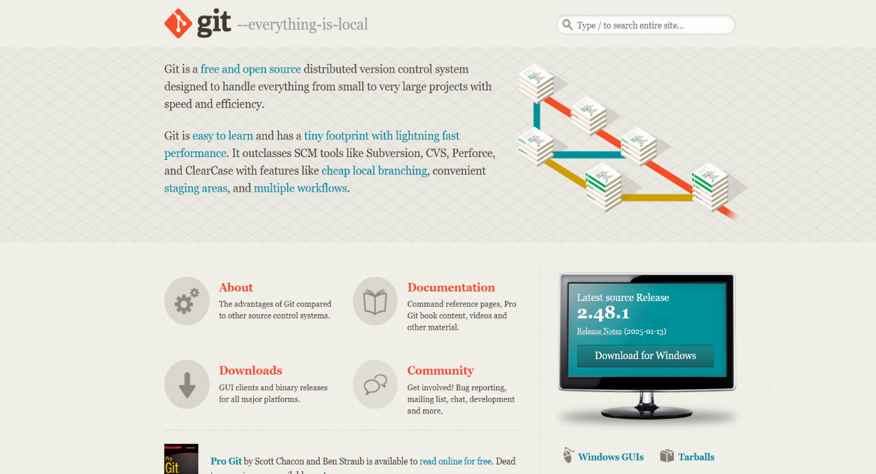

Figure - 1

Step 2: Running the Git Installer
Locate the downloaded Git.exe file and double-click to run it.
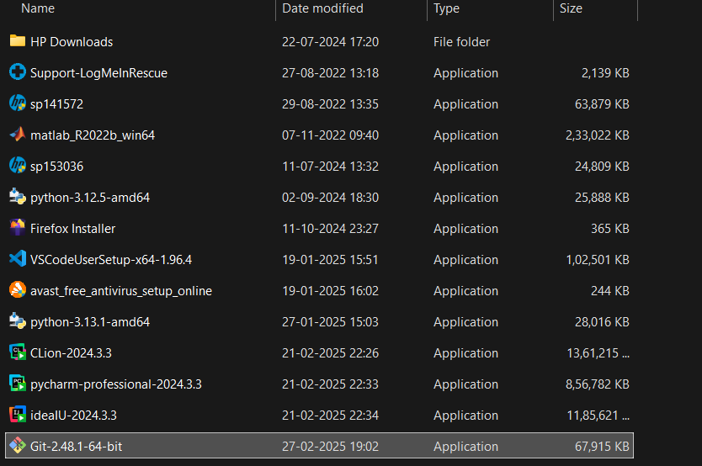

Figure – 2
Step 3: License (Terms and Conditions)
Read the GNU General Public License’s terms and conditions and click on Next.

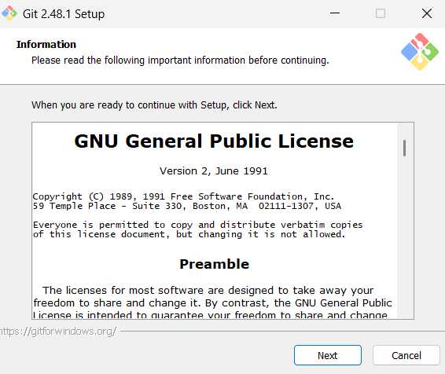

Figure - 3
Step 4: Choose Installation Location
Choose the installation location (default is C:\Program Files\Git) and click Next.
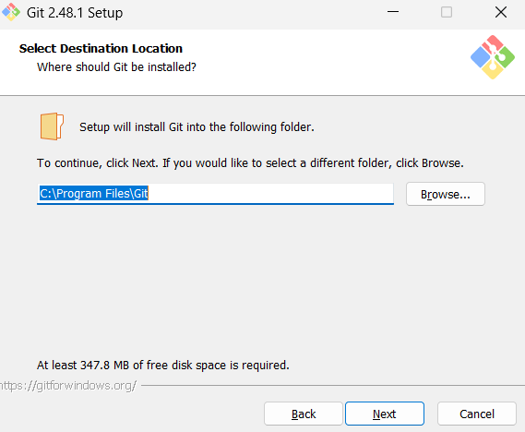

Figure – 4
Step 5: Select the Components
Select the components you want (default options are fine) and click Next.
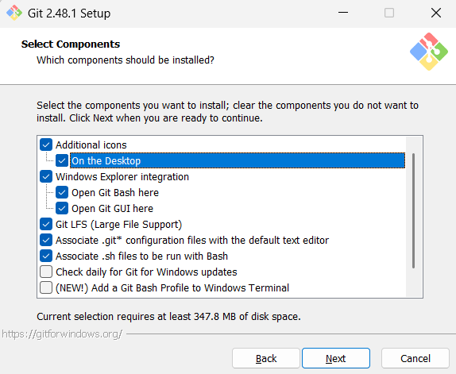

Figure – 5

Step 6: Select Start Menu Folder
Choose the Start Menu folder where Git shortcuts will be placed. By default, the folder is named "Git". Keep the default name and click Next to Proceed.

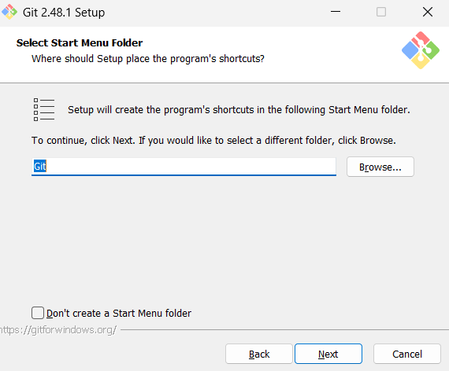

Figure – 6
Step 7: Choose the Text Editor
Choose a default text editor (select Vim) and Click Next.

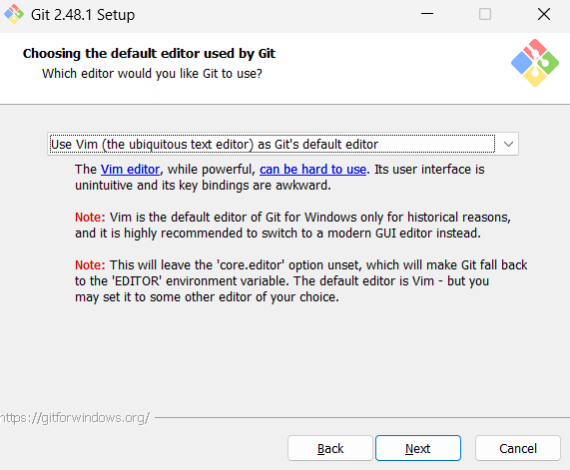
Figure – 7
Step 8: Adjusting Initial Branch Name
Choose the default name for the first branch when initializing a new Git repository. Go with ‘Let Git Decide’ option setting the branch as Master branch and proceed with Next.

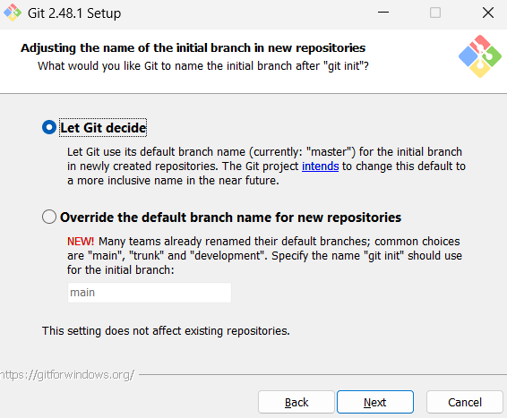

Figure – 8
Step 9: Adjusting PATH Environment
Select Git from the command line and also from third-party software (recommended). Click Next.

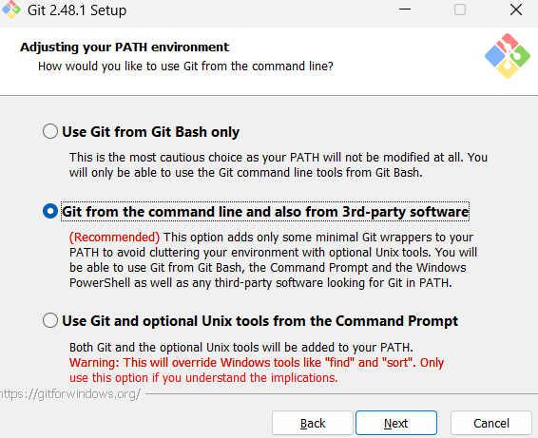

Figure – 9

Step 10: Choosing the SSH Executable
Select "Use bundled OpenSSH" for better compatibility and Click on Next.

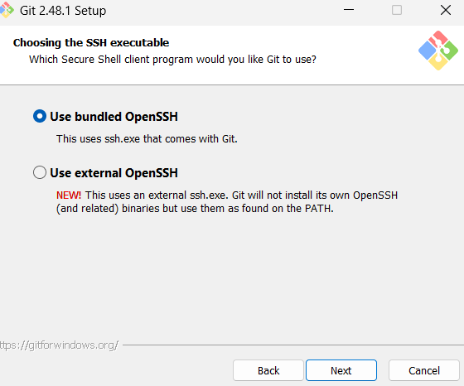

Figure - 10
Step 11: Choosing the HTTP Transport Background
Choose Use the OpenSSL library (default) and Click Next.

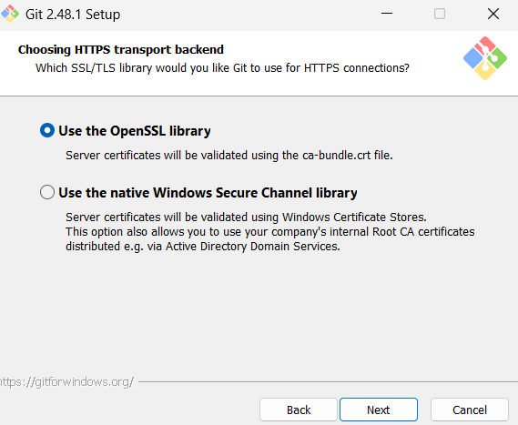

Figure – 11

Step 12: Configuring Line Ending Configs
Select Checkout Windows-style, commit Unix-style line endings (recommended) and Click Next.

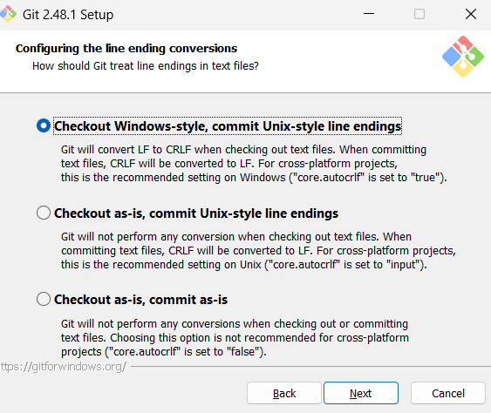

Figure - 12
Step 13: Configuring the Terminal Emulator
Select Use MinTTY (default terminal for MSYS2) and Click Next.
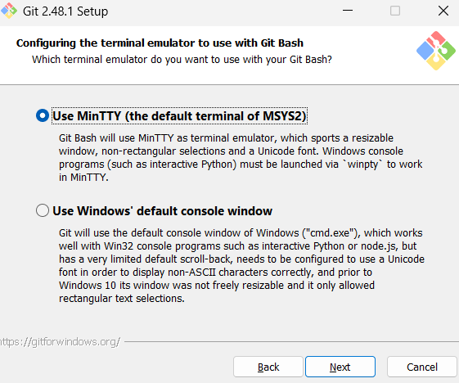

Figure- 13

Step 14: Choosing the Default Behaviour
Select Fast-forward or Merge (recommended) option and click Next.

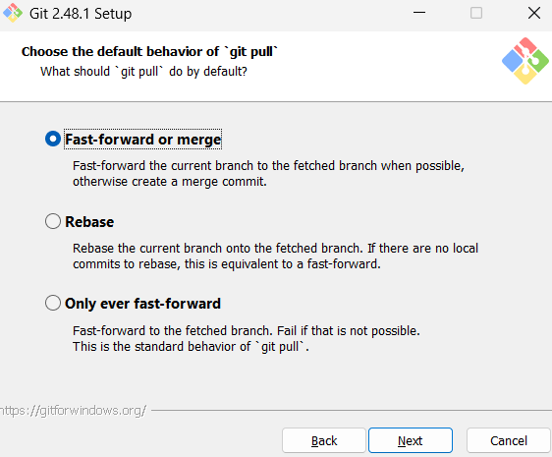

Figure – 14
Step 15: Choosing a Credential Helper
Select Git Credential Manager (recommended) and Click Next.

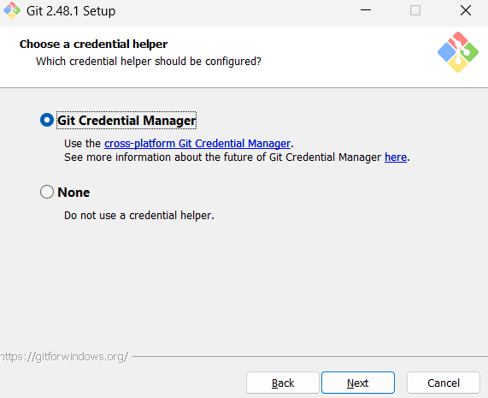
Figure – 15

Step 16: Configuring Extra Options
Select Enable file system caching (recommended) and Click on Install.

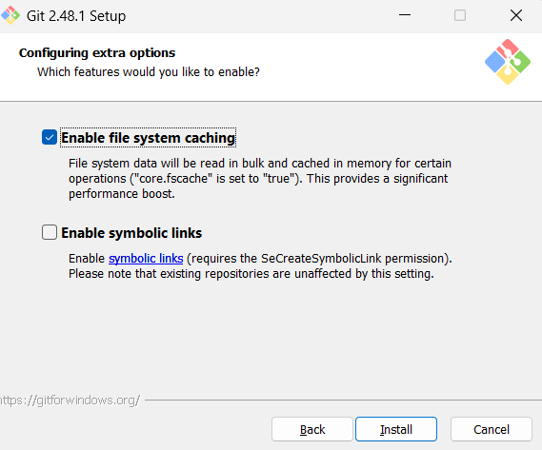

Figure – 16
Step 17: Installation Overview
A progress bar (green bar) will appear, indicating that Git is being installed. Wait for the installation to complete. This may take a few minutes.
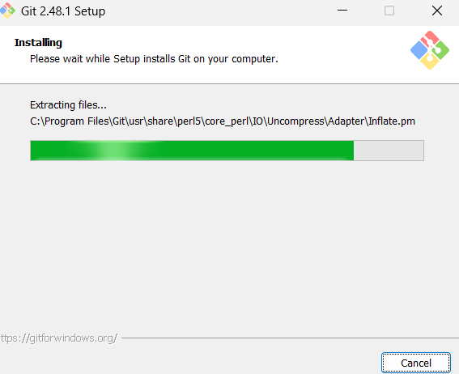

Figure – 17

Step 18: Completing the Git Set - Up Wizard
Once the installation is complete, "Completing the Git Setup Wizard" screen appears. Check the ‘Launch Git bash’ option and Click on Finish.

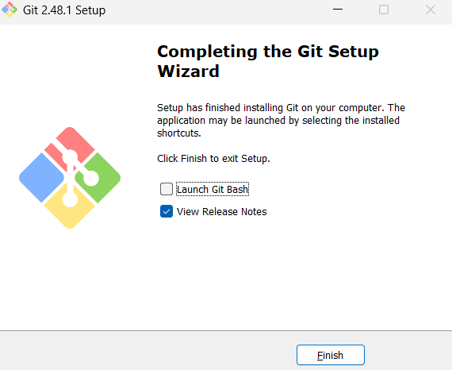

Figure – 18

Source Code Management
LAB REPORT – 2
Step 1: Open Git Bash
Open Git Bash from the Start menu or by searching for it.
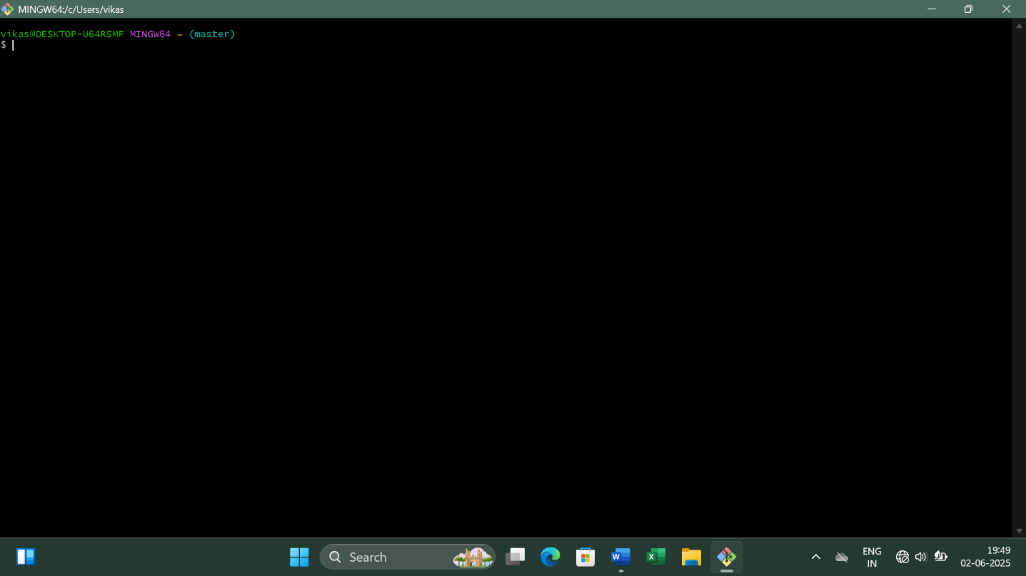

Figure – 1
Step 2: Check Git Version
To verify that Git is installed correctly, run: git –version
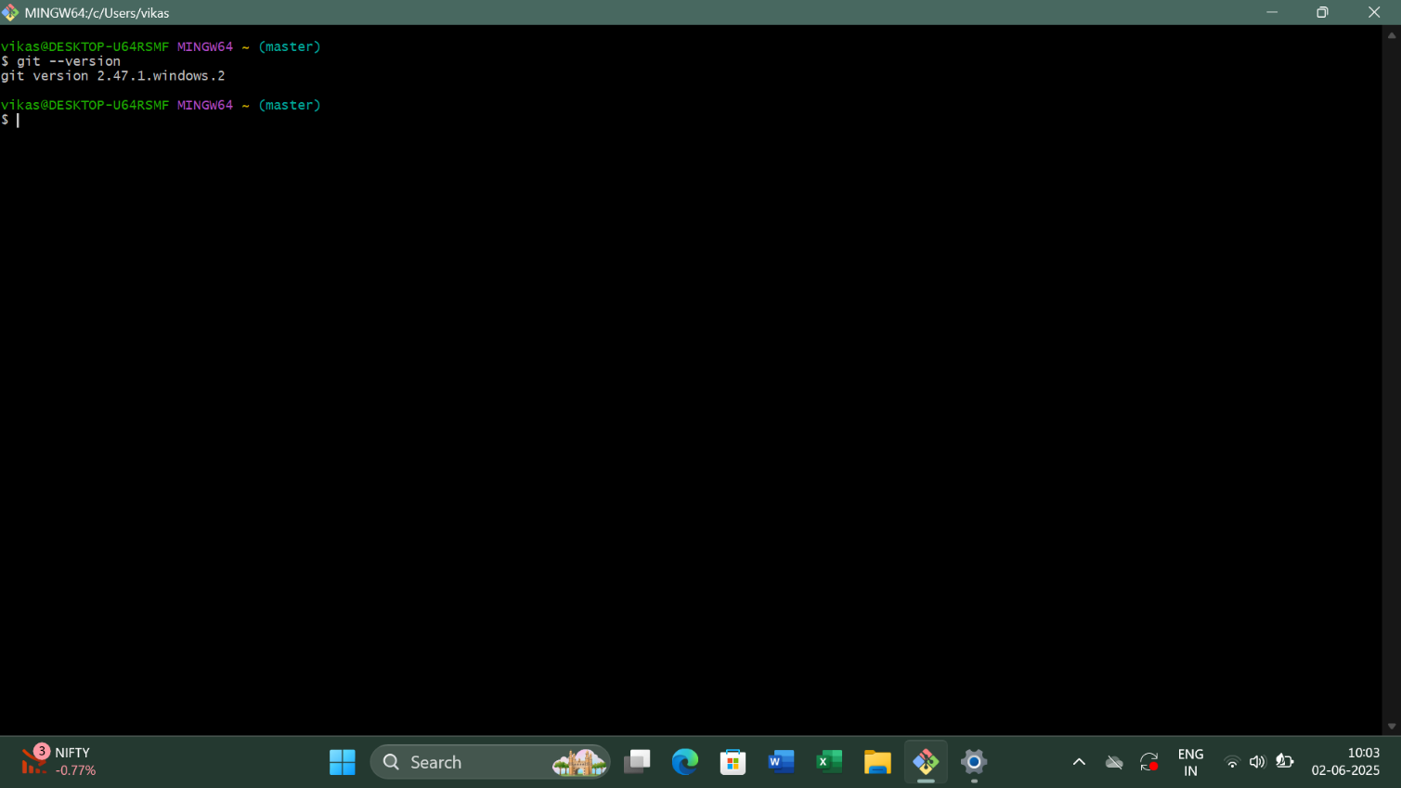

Figure – 2
Step 3: Configure Git
Set up your Git username and email (required for commits):
- git config --global user.name "Your Name"
- git config --global user.email “your-email@example.com”
- 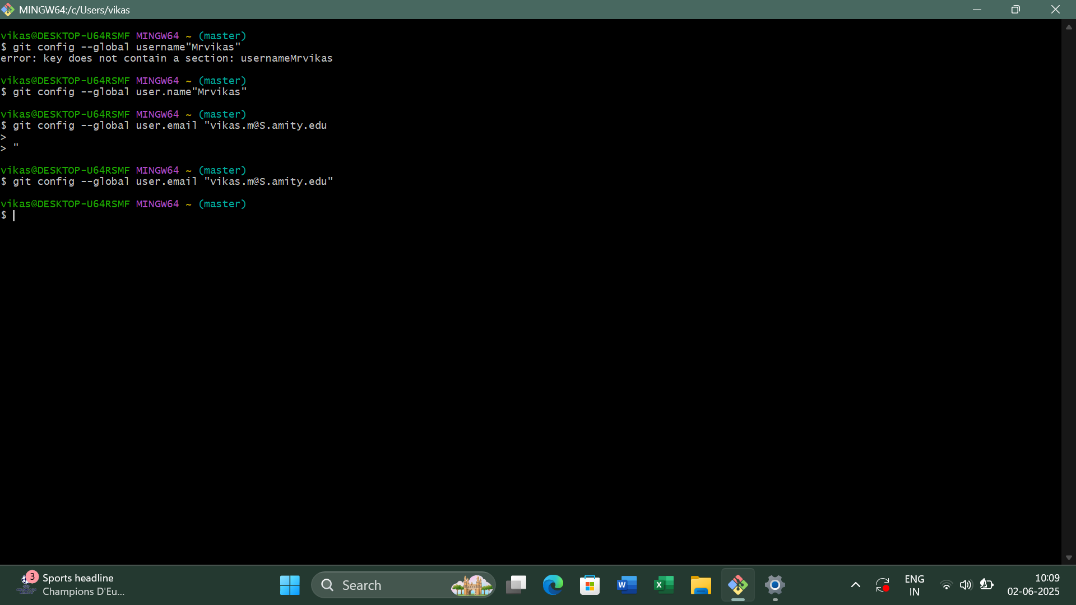

Figure – 3
Step 4: Verify Git Configurations
To check if the configurations were set correctly, run:
- git config --list
- 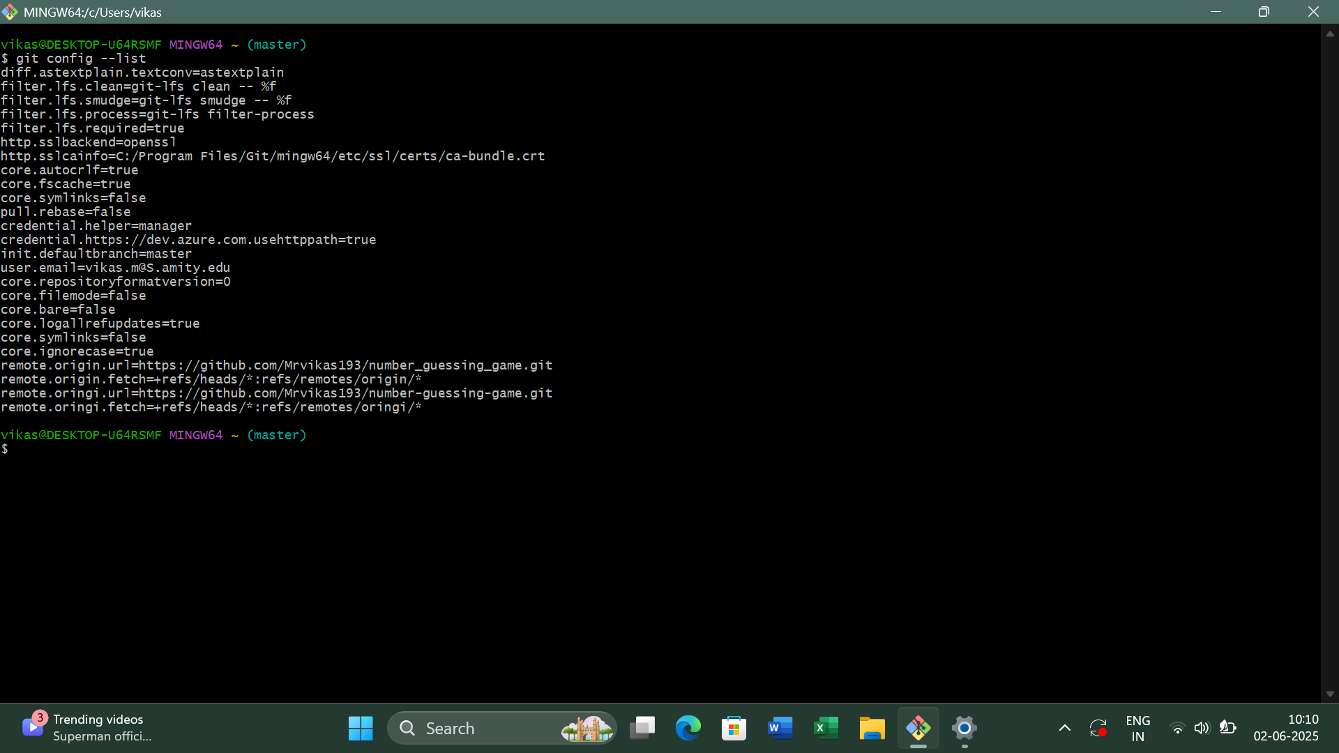

Figure – 4
Step 5: Change Directory
Change directory (cd) to your preferred location using the ‘cd’ command.
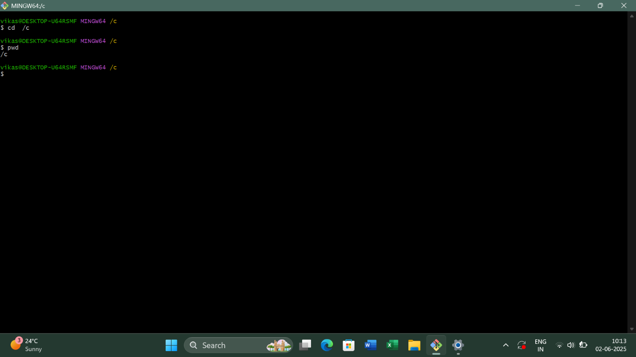

Figure – 5
Step 6: Create a New Folder
To Create a new folder in the Directory, use the command: mkdir folder-name.
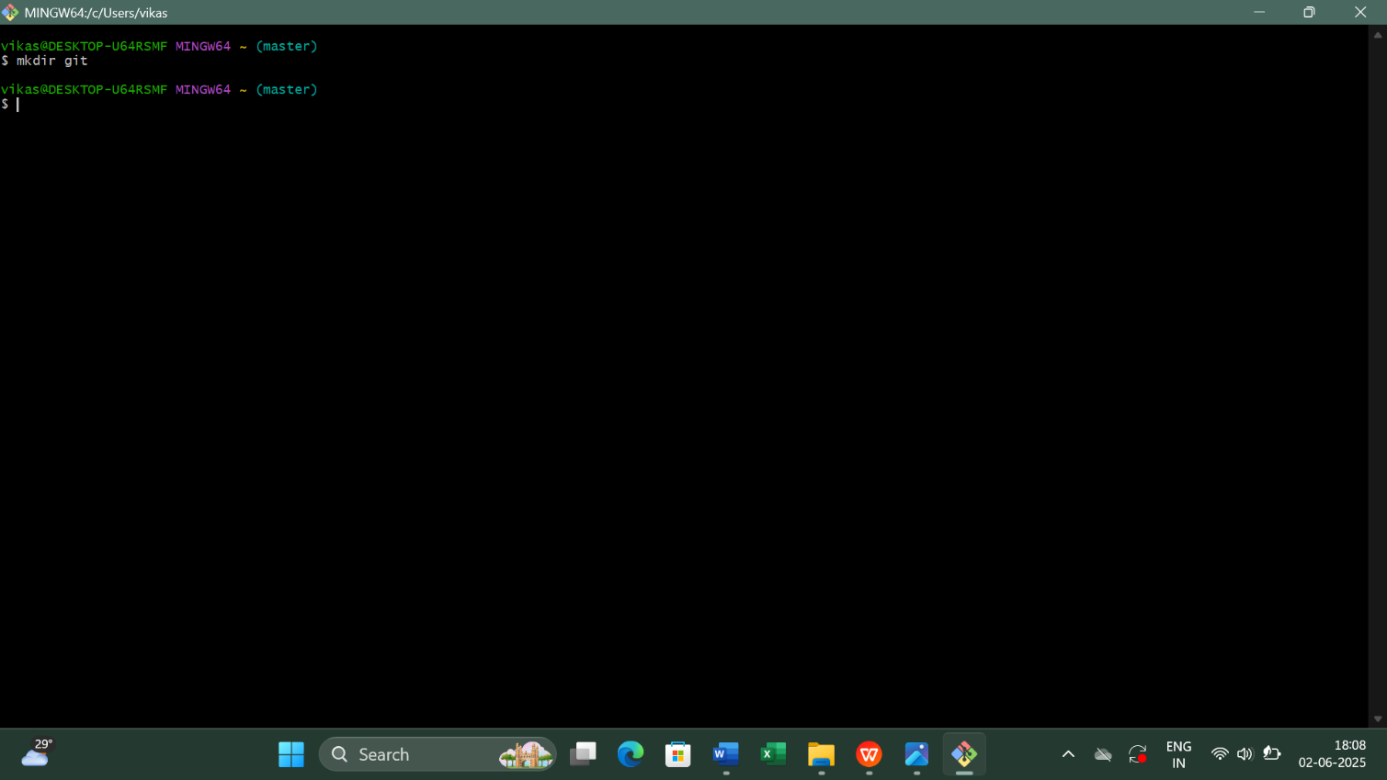

Figure – 6
Step 7: Print the Current Directory
To print the full path of your current Directory use the ‘pwd’ command.
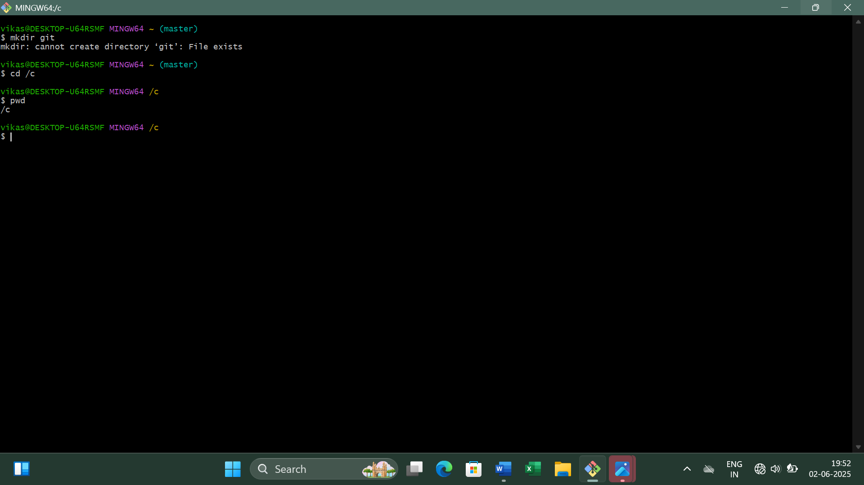

Figure – 7

Step 8: Listing the Files and Folders
To Display the list of all files and folders in the current directory use the ‘ls’ command.

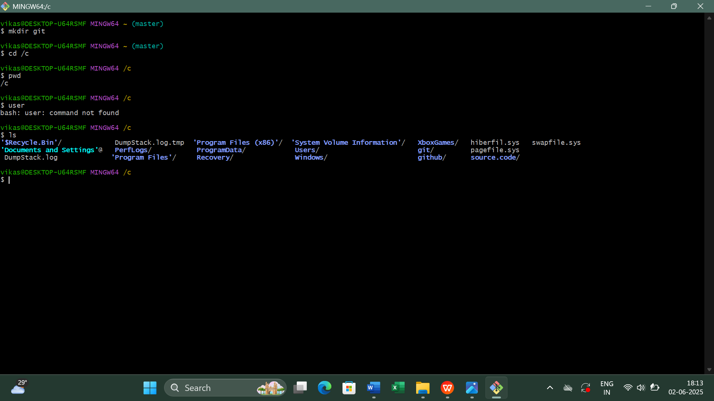

Figure – 8
Step 9: Creating a File Inside the Folder
To create a C++ File inside the Git Folder, move inside the folder using the ‘cd’ command and then use ‘vi’ command to create a file.
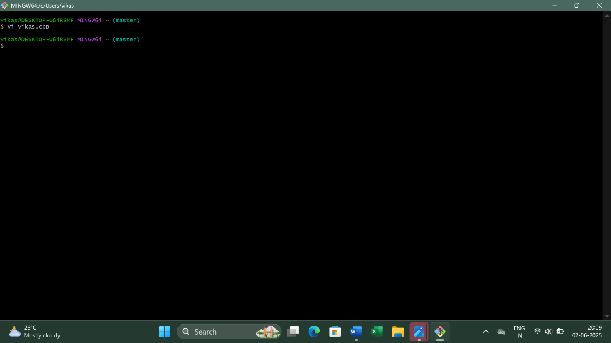

Figure – 9

Step 10: Inside the VI Editor
Once typed Git opens the ‘vi’ editor to create or edit a file named Hello.cpp. Press i to enter INSERT mode. Now start typing your code in the vi Editor.
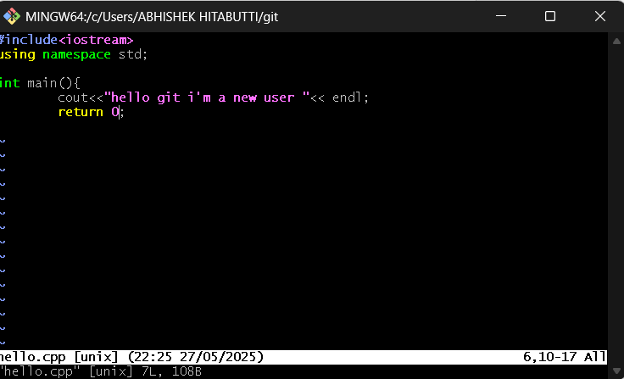

Figure – 10
Step 11: Exiting the VI Editor
Once done with the code Press ESC to exit INSERT mode and type :wq and press Enter to save and exit.
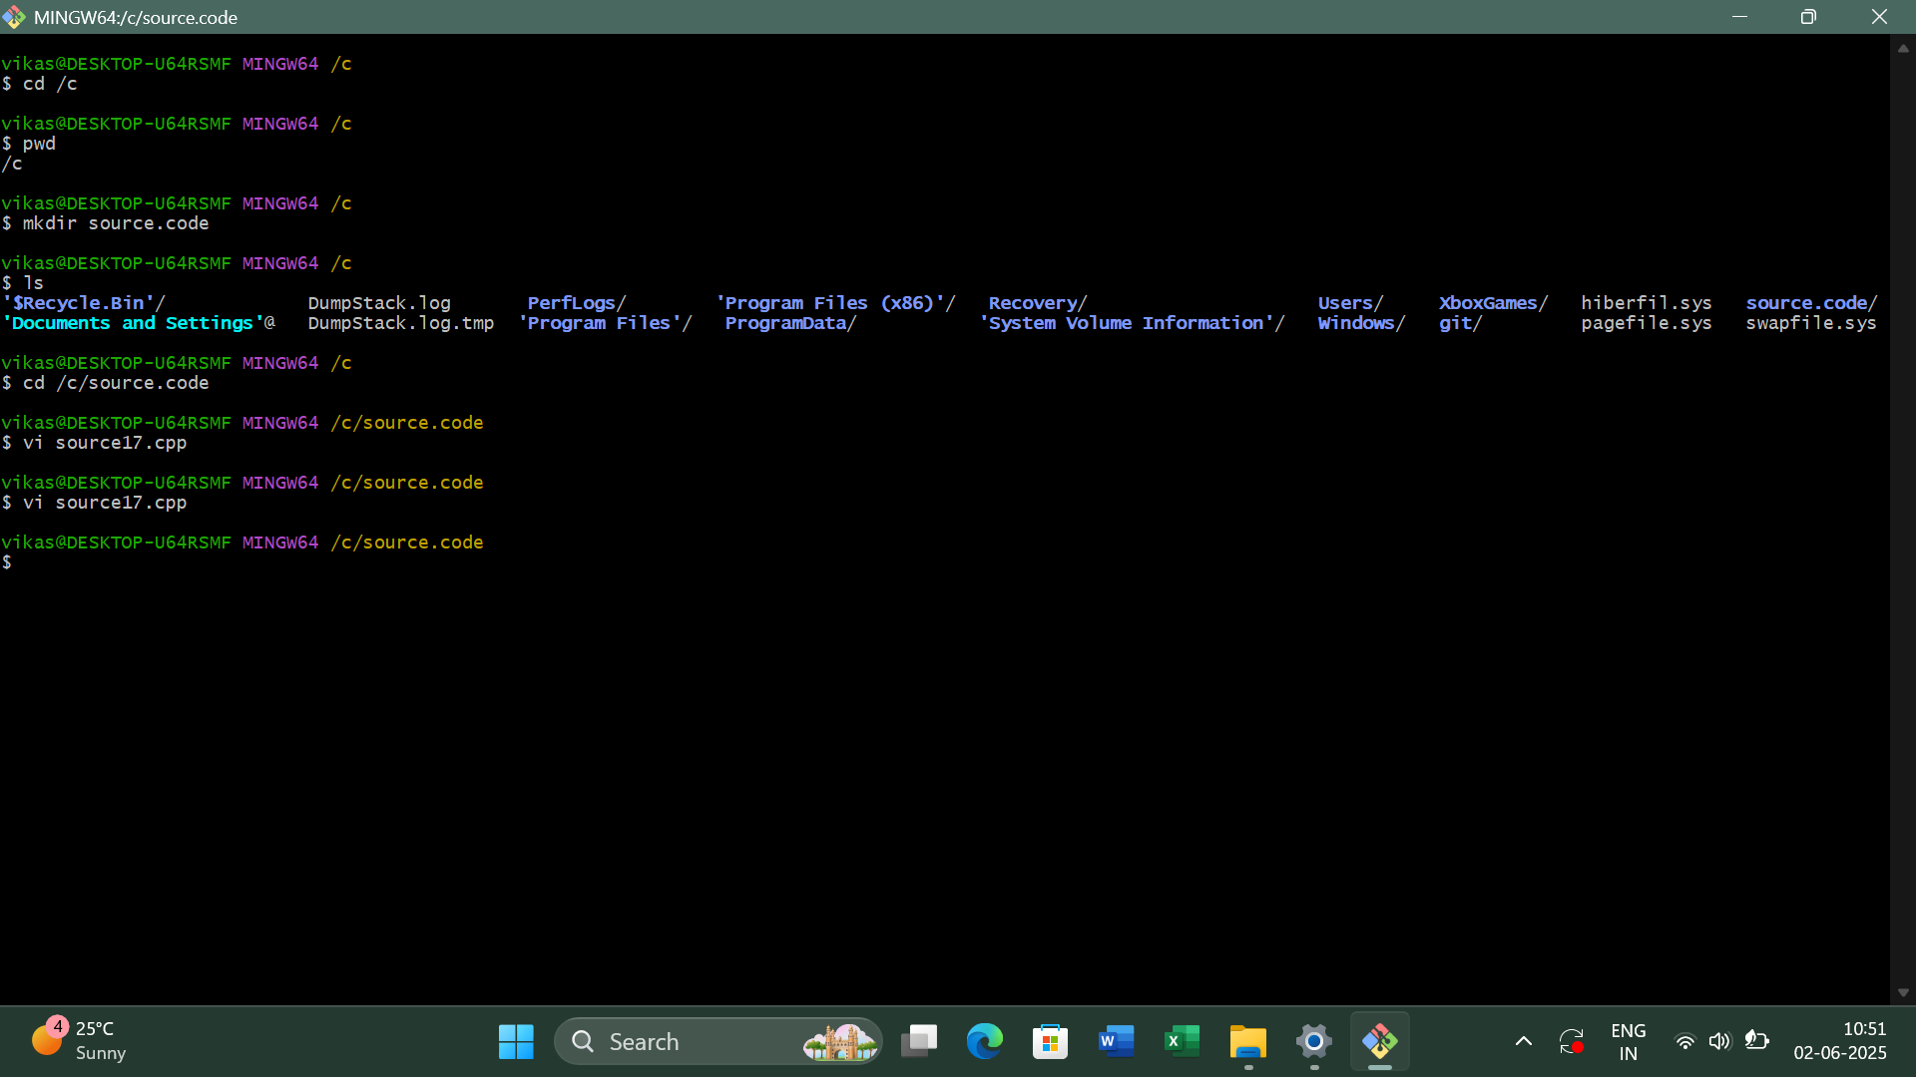

Figure – 11
Step 12: Display File Contents
To Display the contents of the CPP File use the cat Command as: cat filename.extension.

Figure – 12
Step 13: Initialize Git in Directory
To turn the directory into a Git repository, run: git init
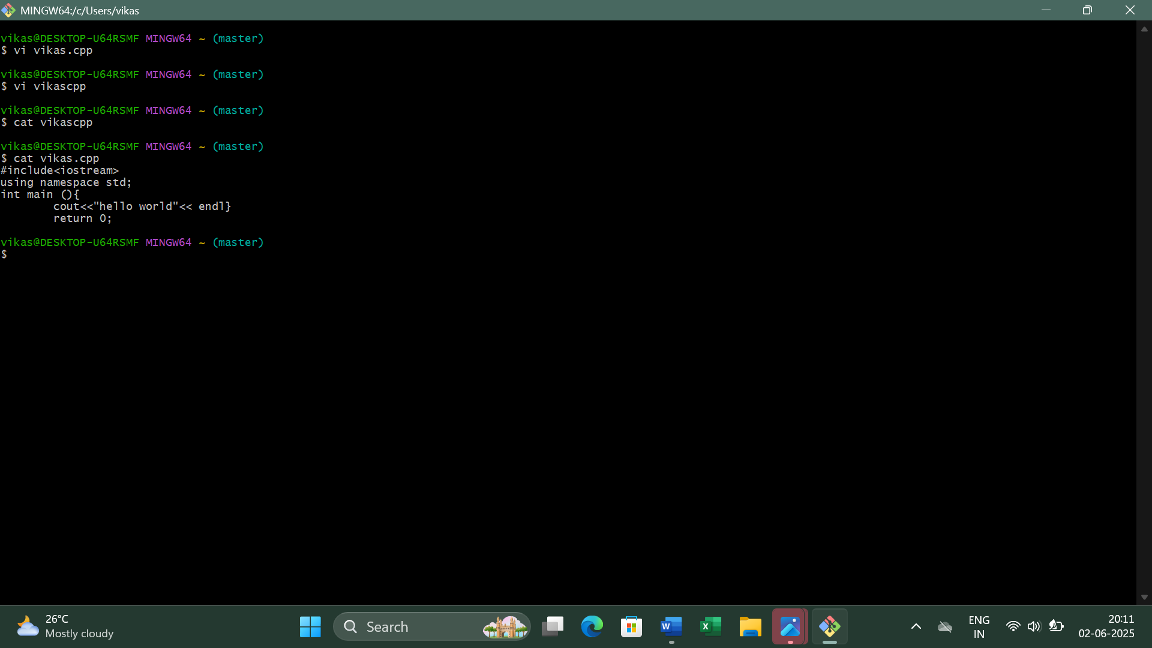

Figure – 13
Step 14: Check Git Status
The git status command is used to check for untracked files, along with other changes in the repository. You should see Hello.cpp as an untracked file.
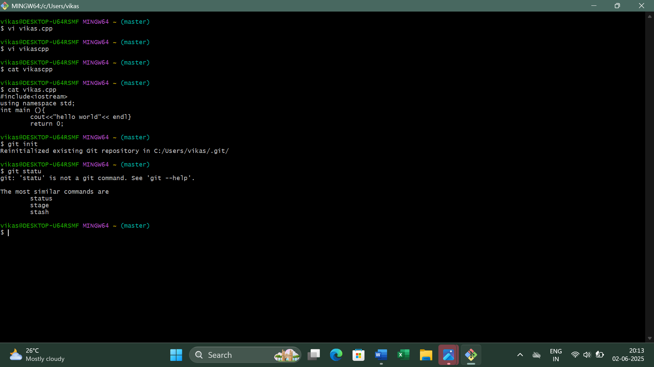

Figure – 14
Step 15: Add Files to Staging Area
To stage all newly created and modified files use the command: git add .
To confirm, check the status again using the command: git status
Now, all tracked files will appear as staged.
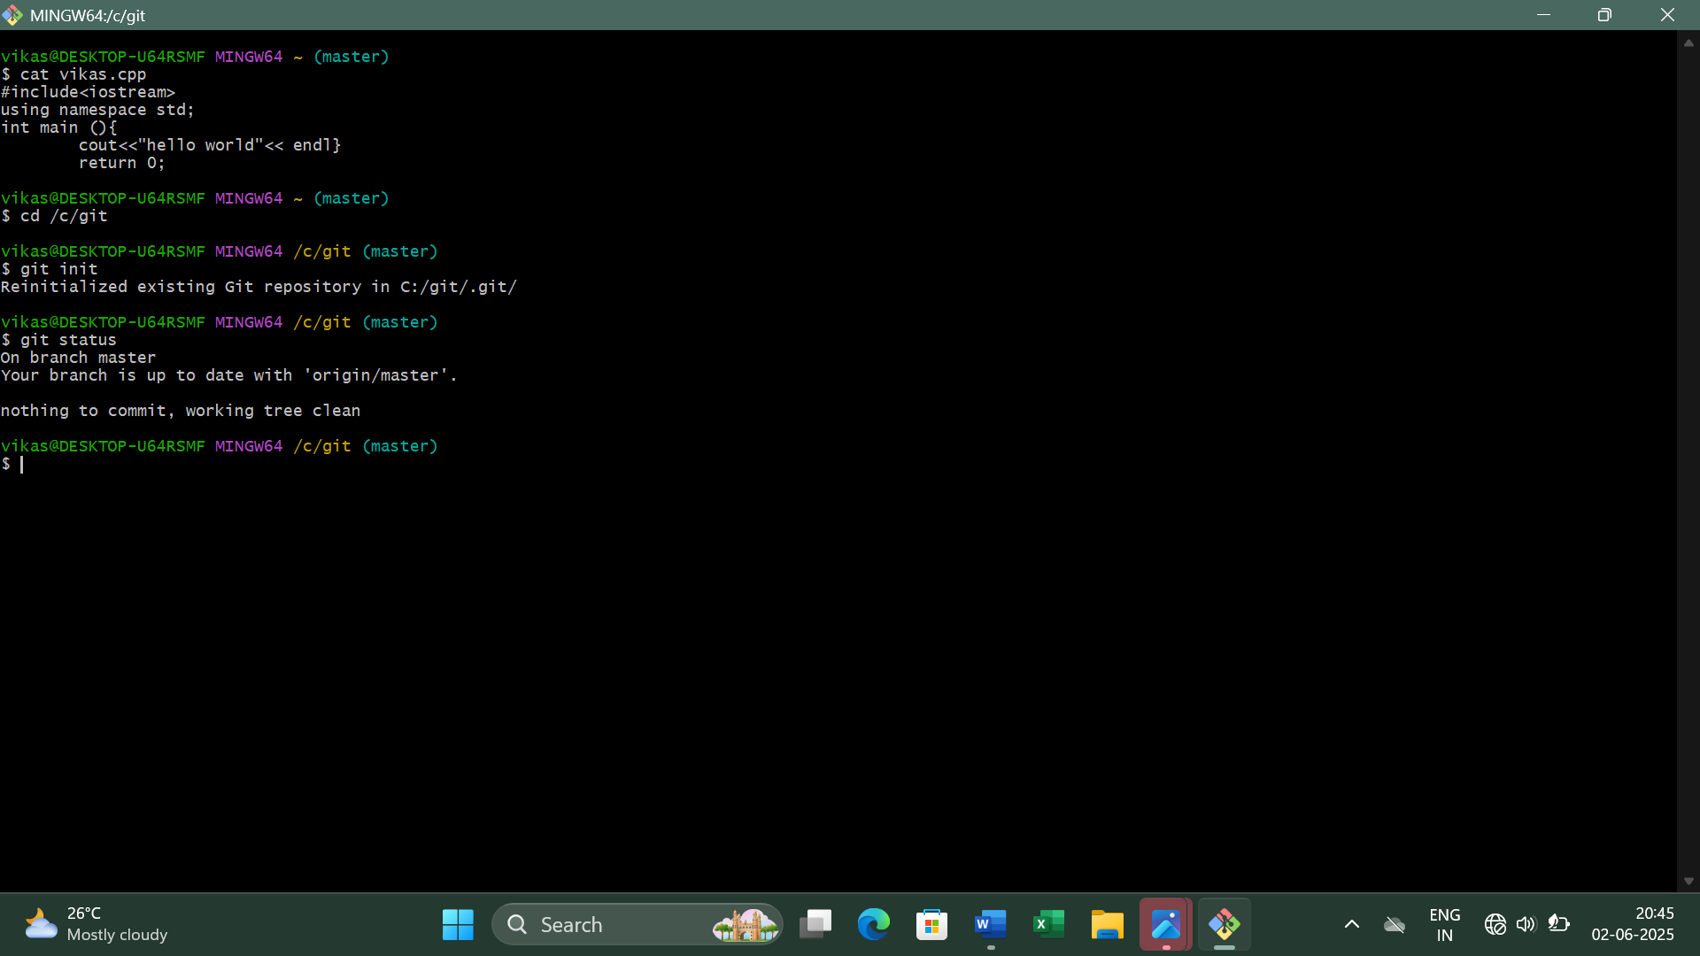

Figure – 15
Step 16: Commit the File
To save commit: Added main.cpp"the changes in Git, commit the file with a message: git commit -m "Initial
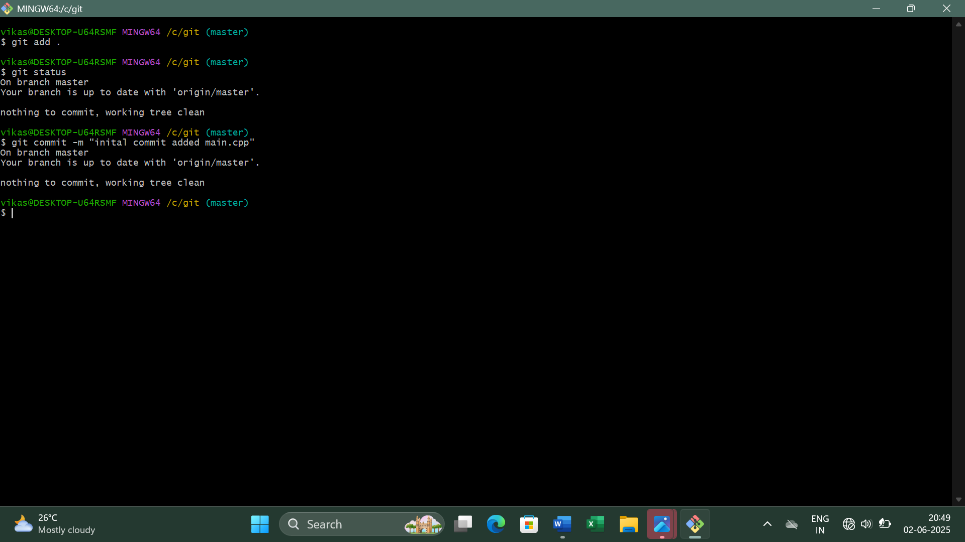

Figure – 16
Source Code Management
LAB REPORT – 3
Step 1: Check Git Commit History
• The git log command displays the commit history in detail.
• It shows the commit hash, author, date, and commit message.
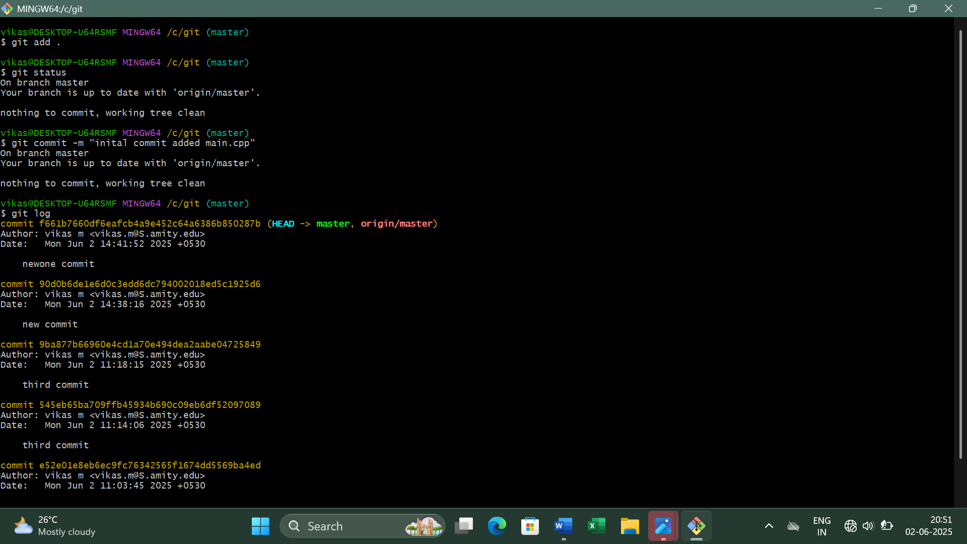

Figure – 1
Step 2: View Git Log in One Line Format
• The git log --oneline command displays a compact version of the commit history.
• It only shows the commit hash and the commit message.
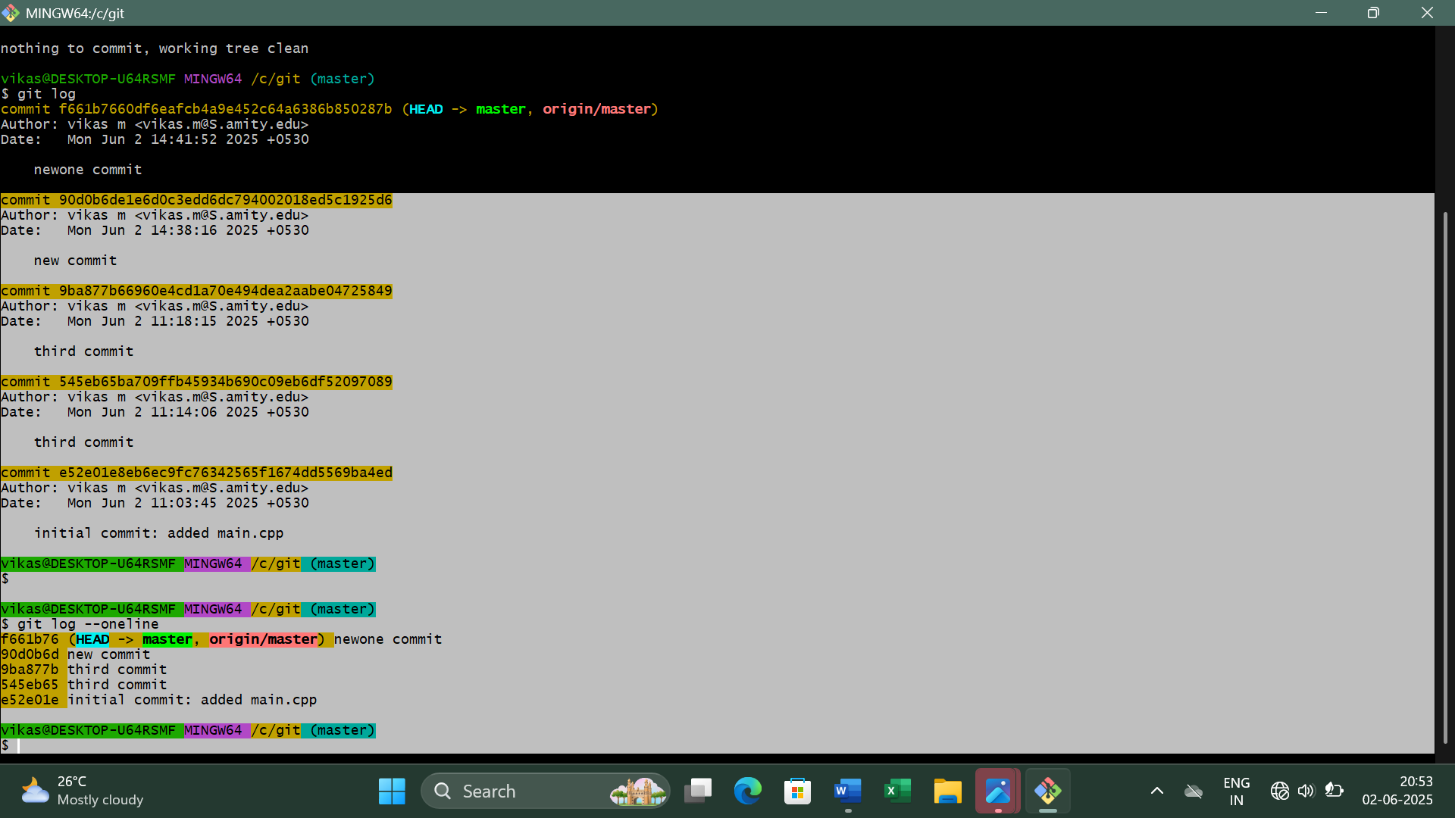

Figure – 2
Step 3: Modify the Hello.cpp File (First Change)
• Open the Hello.cpp file in a text editor using the vi command.
• Make a small change (e.g., add a new function or modify a print statement).
• Save the file and display it using the cat command.
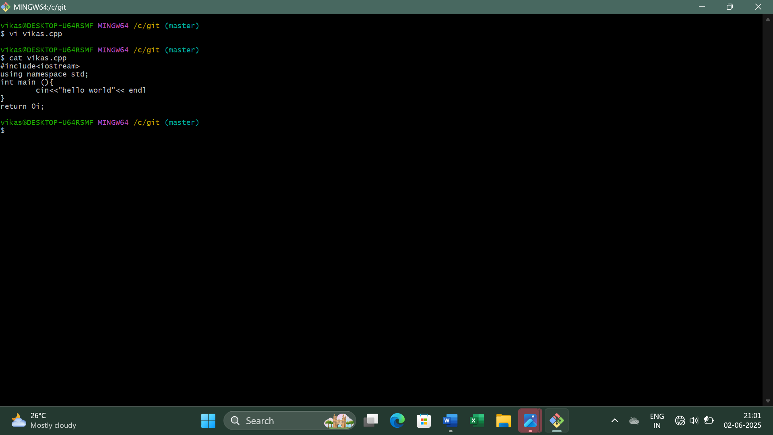

Figure – 3
Step 4: Stage and Commit the First Change
Use git add . command to stage the modified file for commit and git commit -m to create a commit with a message describing the change.
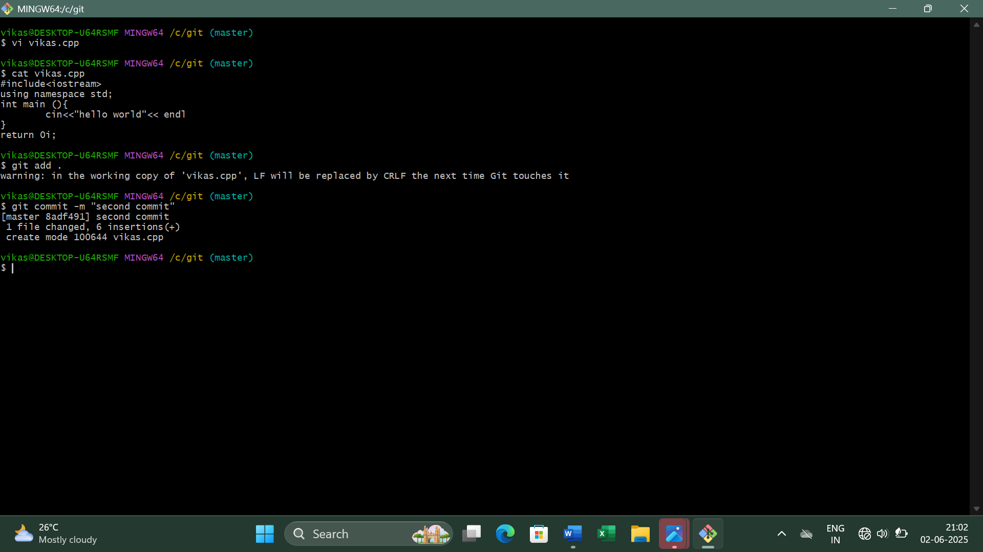

Figure – 4
Step 5: Modify the Hello.cpp File Again (Second Change)
• Make another change in the same Hello.cpp file.
• Example: Modify a different function or add a new comment.
• Save the file and commit it.
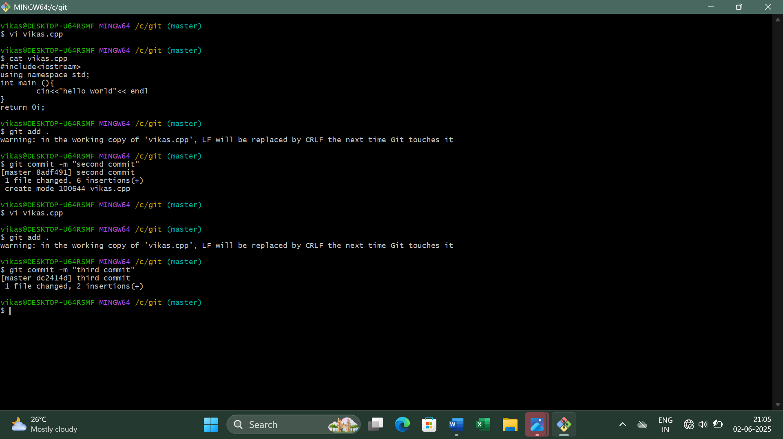

Figure – 5
Step 6: View Git Log Again in One Line Format
This will now show the latest two commits along with previous commits.
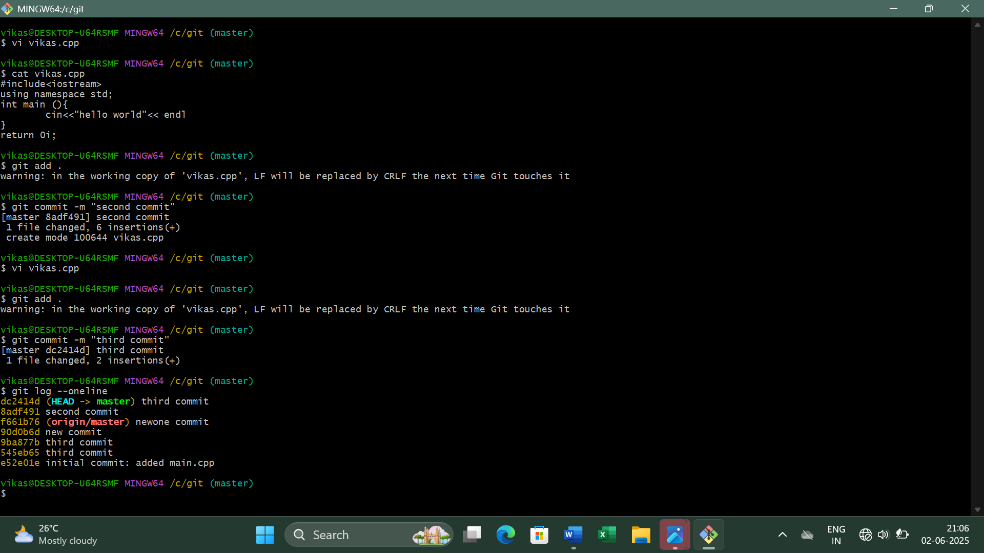

Figure – 6

Step 7: View Differences Between Commits
The git diff command shows the exact lines changed between each commits. You can compare between multiple commits. Example: First commit and Second commit or Second commit and Third commit or even multiple commits.
This shows changes between the First commit and Second commit.
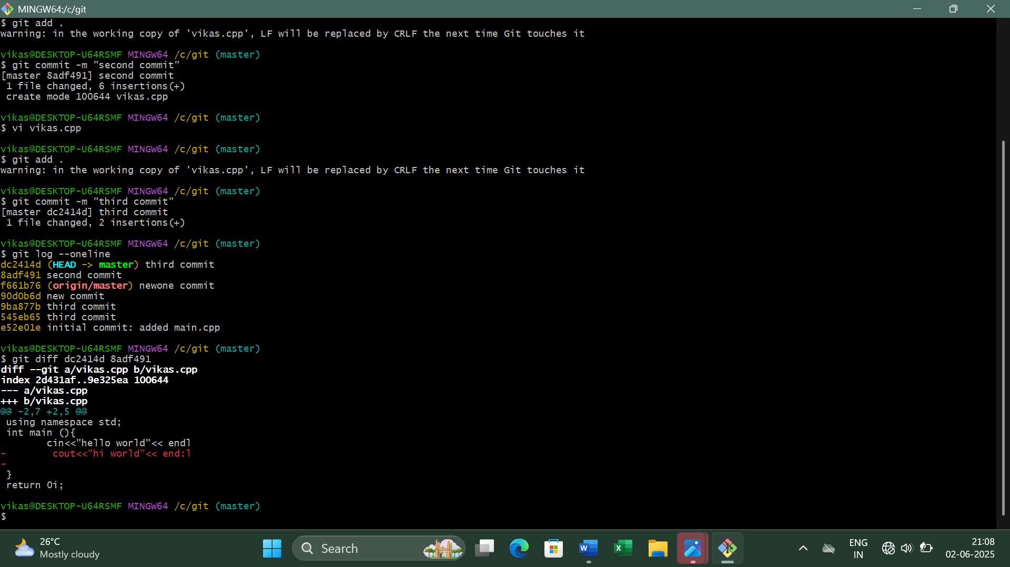

Figure – 7
This shows changes between the Second commit and Third commit.
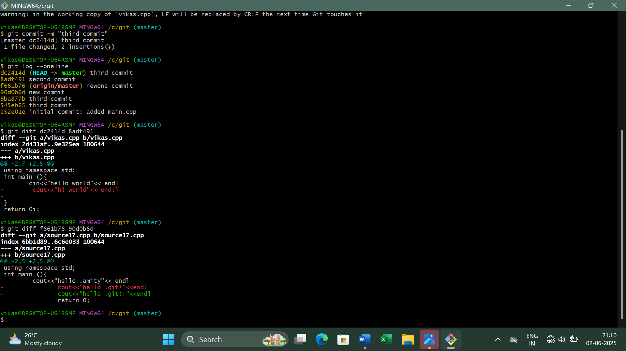

Figure – 8

Source Code Management
LAB REPORT – 4
Step 1: Sign in to GitHub
Open a web browser and go to github.com

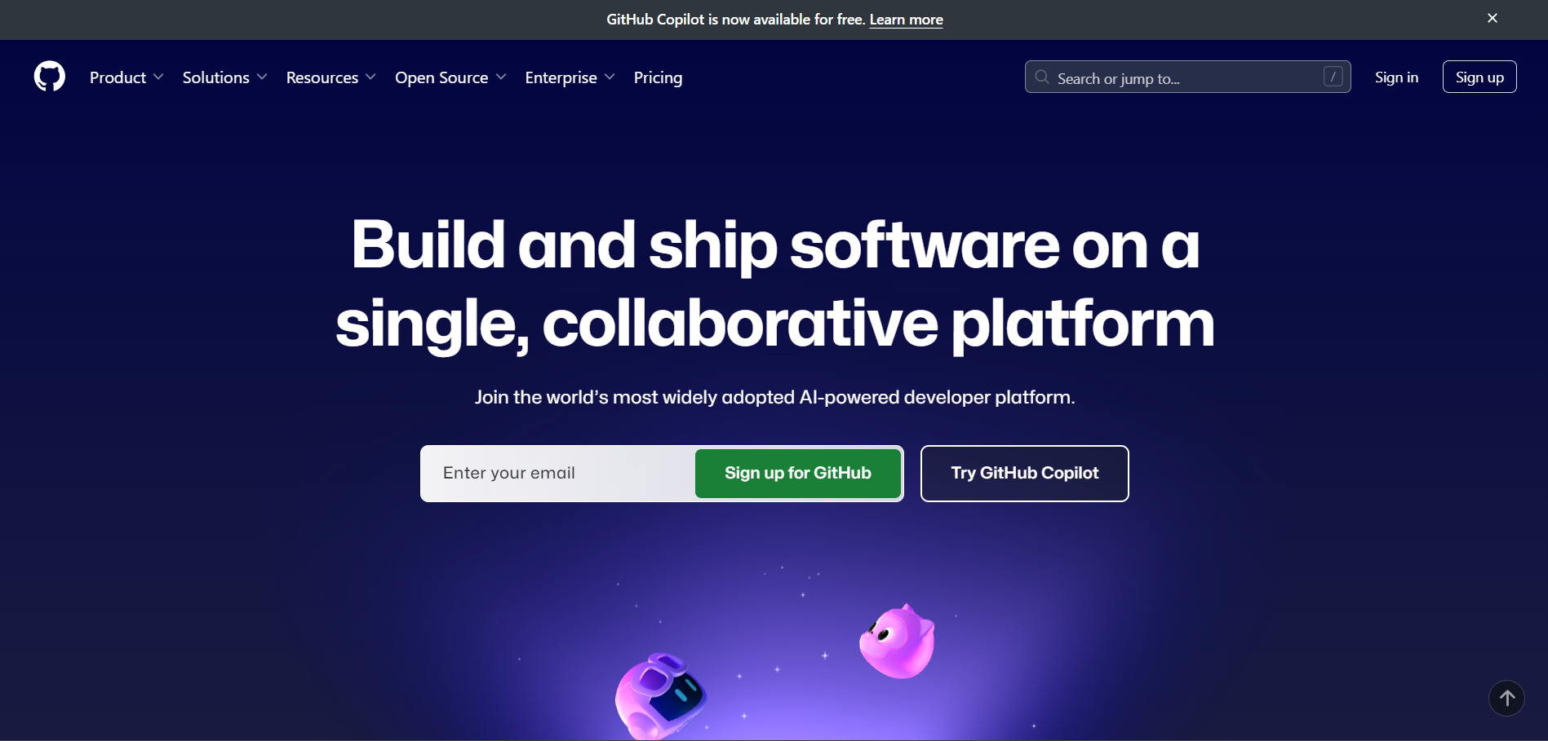
Figure – 1
Click Sign in and enter your credentials.
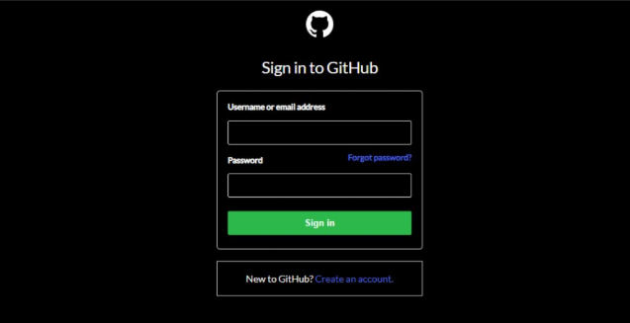

Figure – 2
Step 2: Creating a Repository
Click on the "+" icon (top-right corner) and select "New repository".

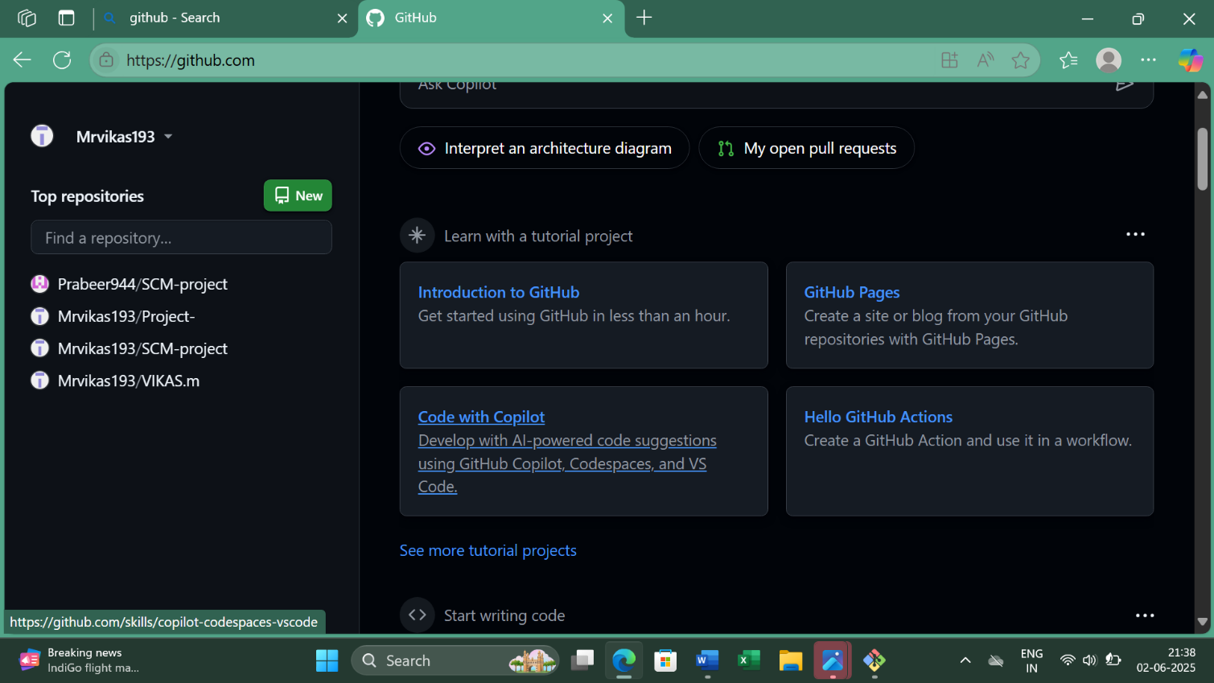

Figure – 3
In the Repository name field, enter the same name as your local folder. Select Public. Do not check "Initialize this repository with a README". Click Create repository.
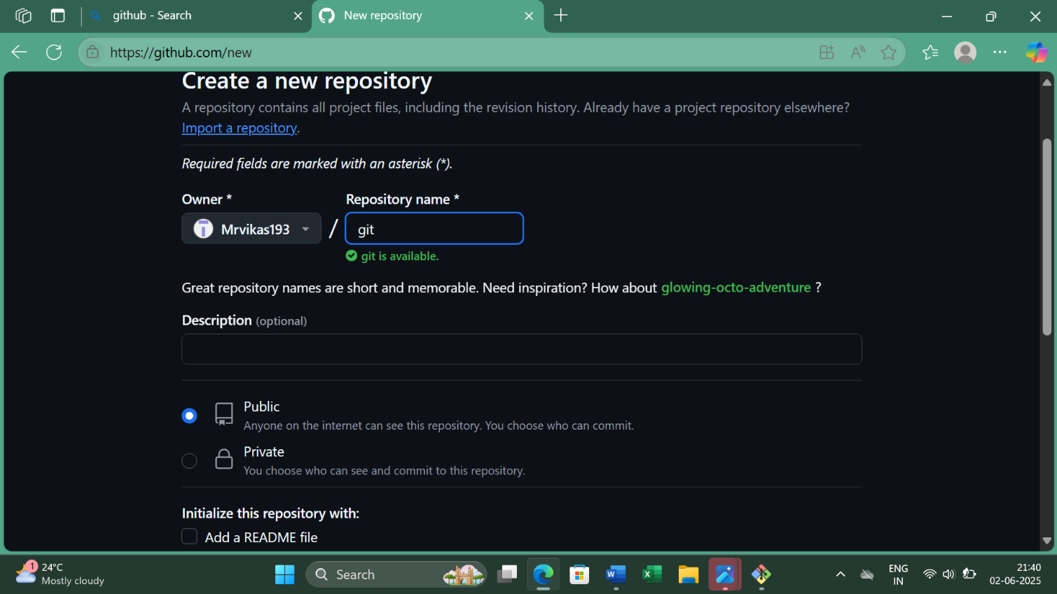

Figure – 4
Step 3: Connect Local Repository to GitHub
On the next page, copy the HTTPS URL under "Quick setup" it looks like (https://github.com/yourusername/repositoryname.git).
Add the GitHub repository as a remote:
- git remote
- git remote add origin <repository-URL>
- 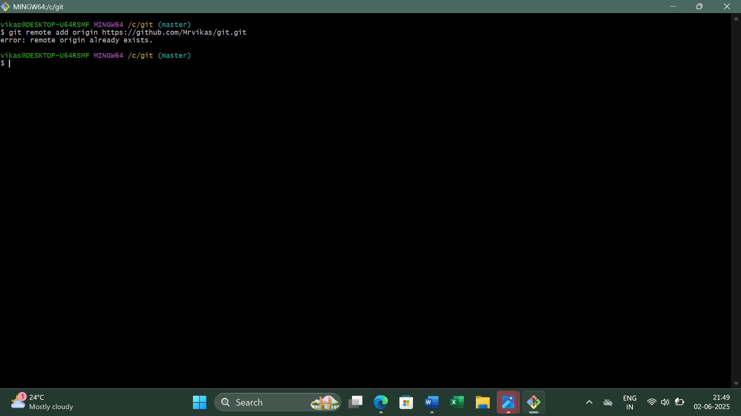

Figure – 5
Step 4: Push Code To GitHub
Push the committed files to GitHub using the command: git push -u origin master

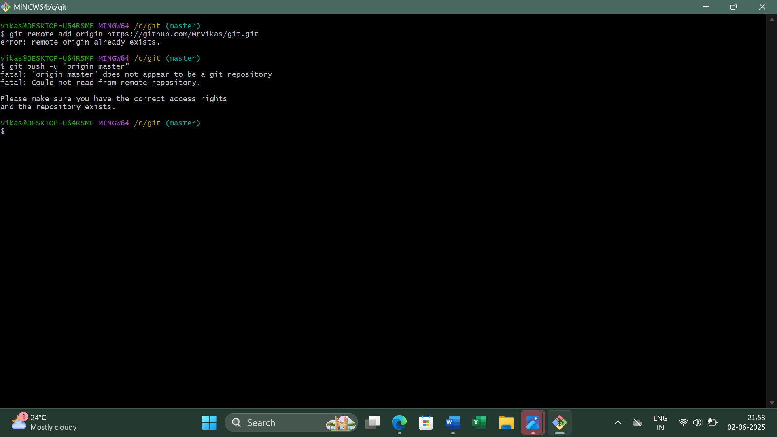

Figure – 6
Step 5: Verify Changes on GitHub
1. Open GitHub in your browser.
2. Go to your repository.
3. Refresh the page – your files should be visible in the repositor
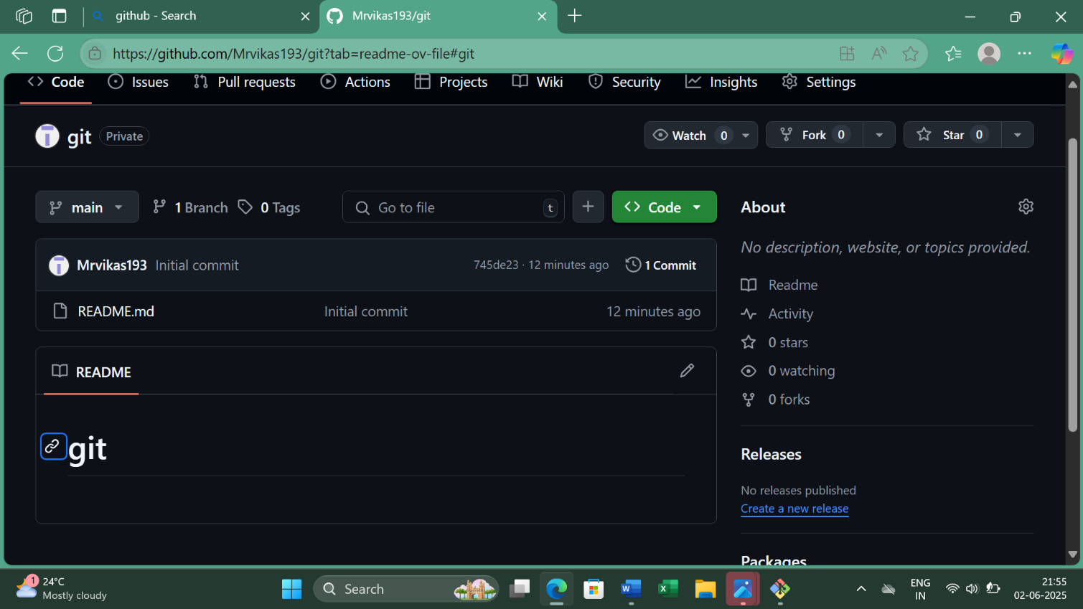

Figure – 7
Step 6: Edit the File Directly on GitHub
1. Click on Hello.cpp file in your GitHub repository.
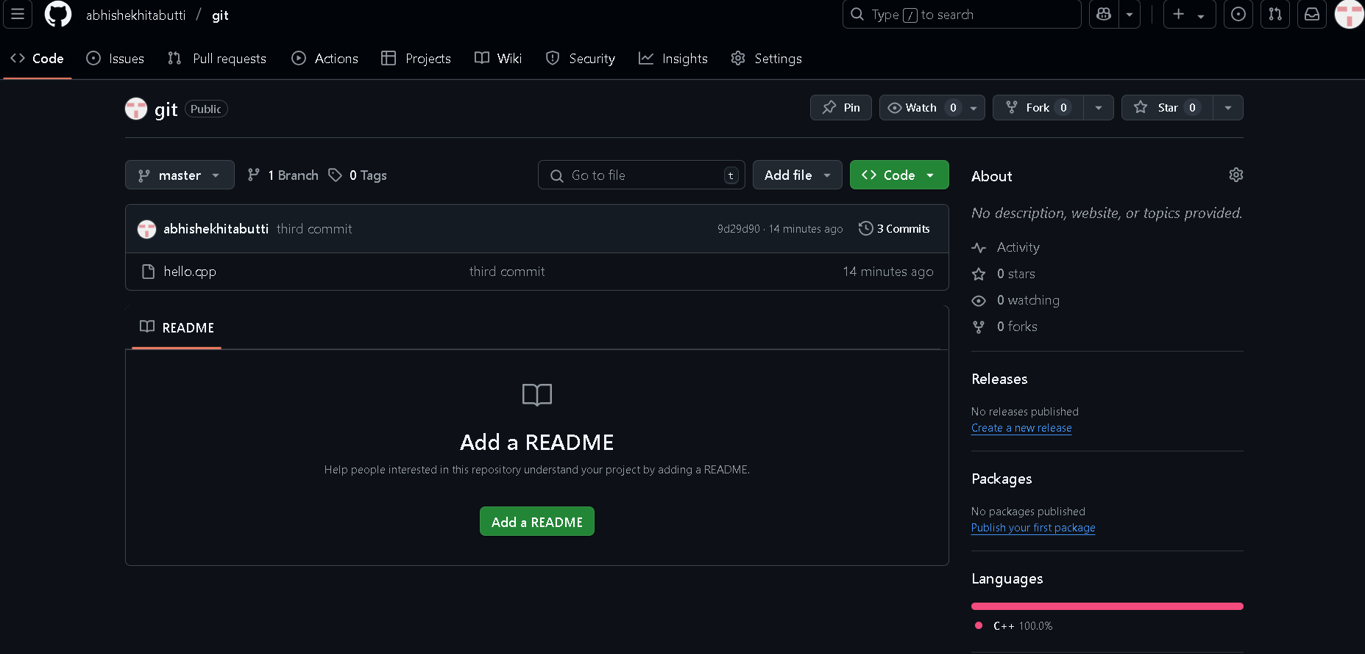

Figure – 8

2. Click the edit (pencil) icon in the top-right.

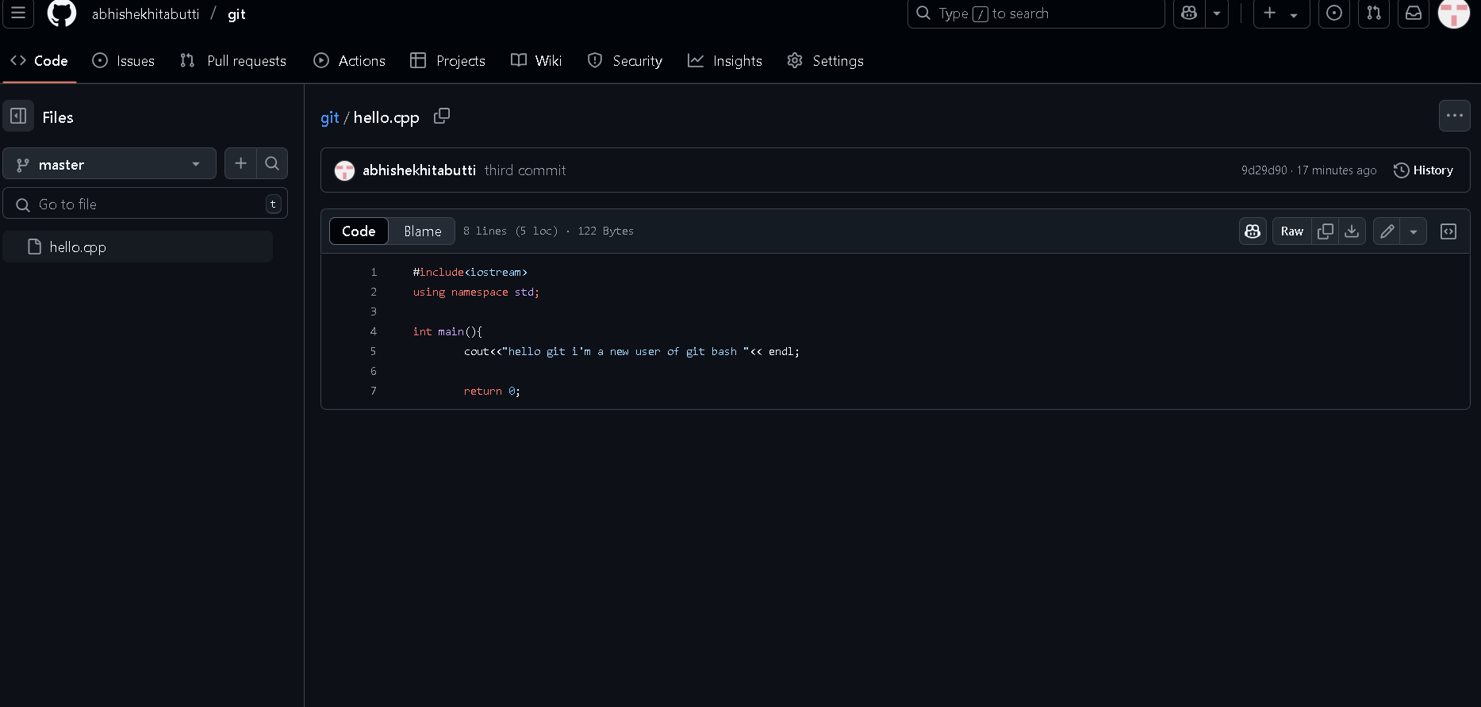

Figure – 9

3. Make some changes to the file, scroll down, enter a commit message, and click Commit changes.

Figure – 10

Step 7: Pull Changes from GitHub to Local System
Open Git Bash in your project folder and Pull the latest changes from GitHub using the
command: git pull
The updated file will now be available on your local system.

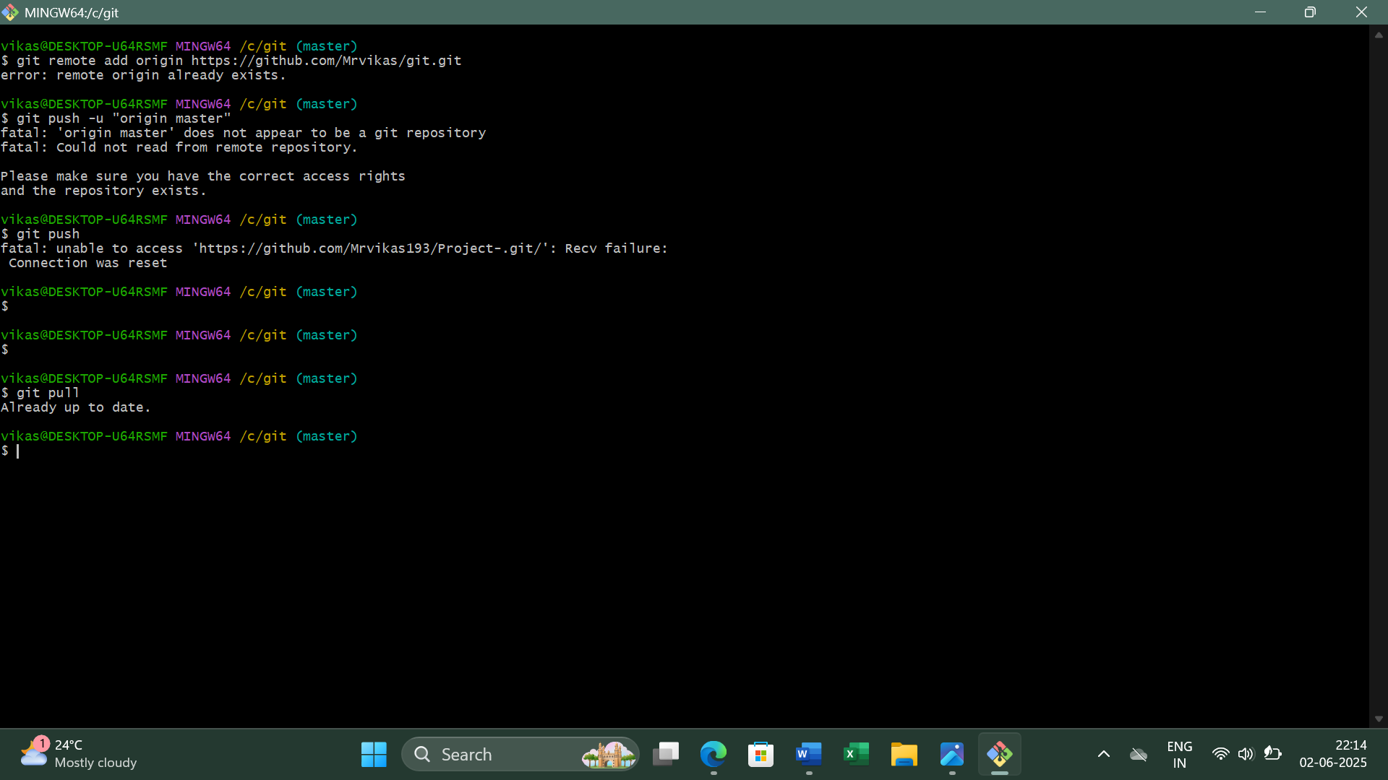

Figure – 11
Use git log to see the changes in your local repository file.
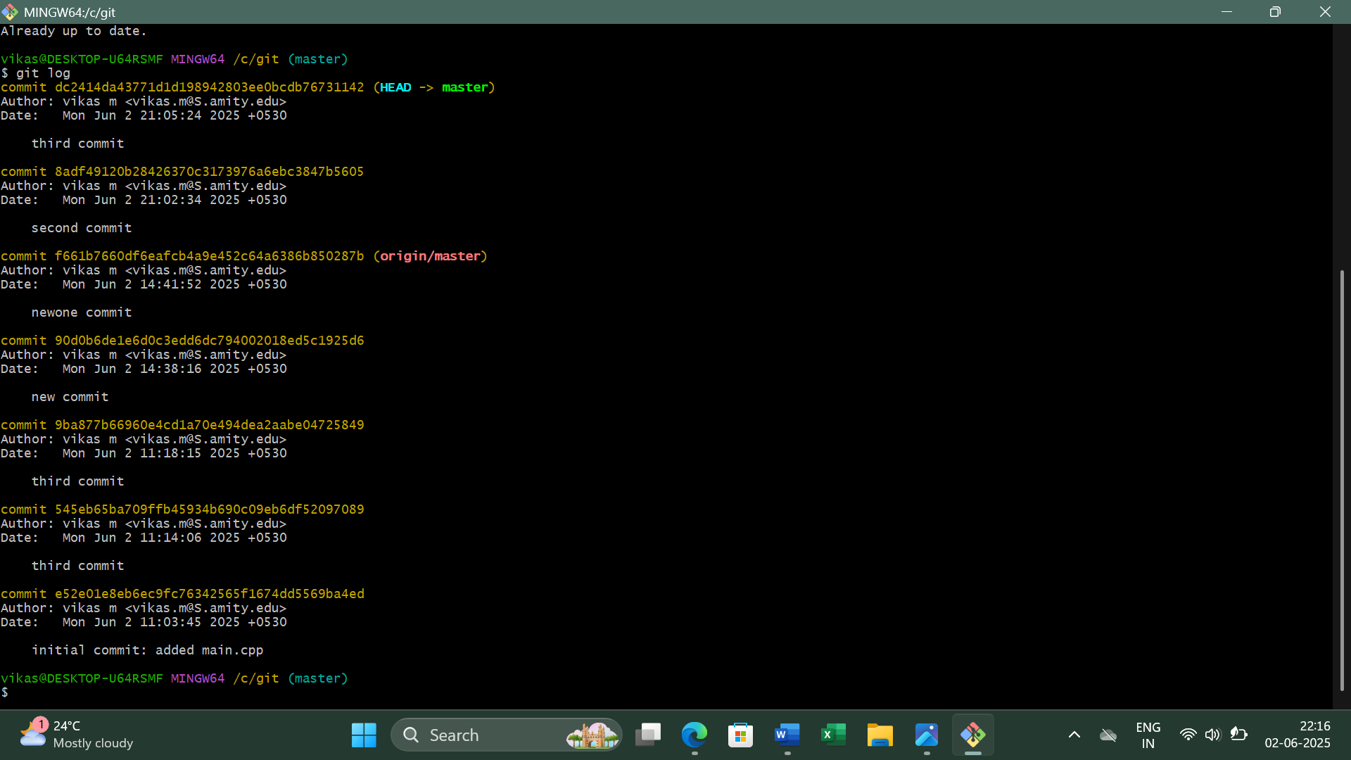

Figure – 12

Source Code Management
LAB REPORT – 5
Step 1: Create a New Branch
Use the following command to create a new branch named dev and switch to it:
git checkout -b dev
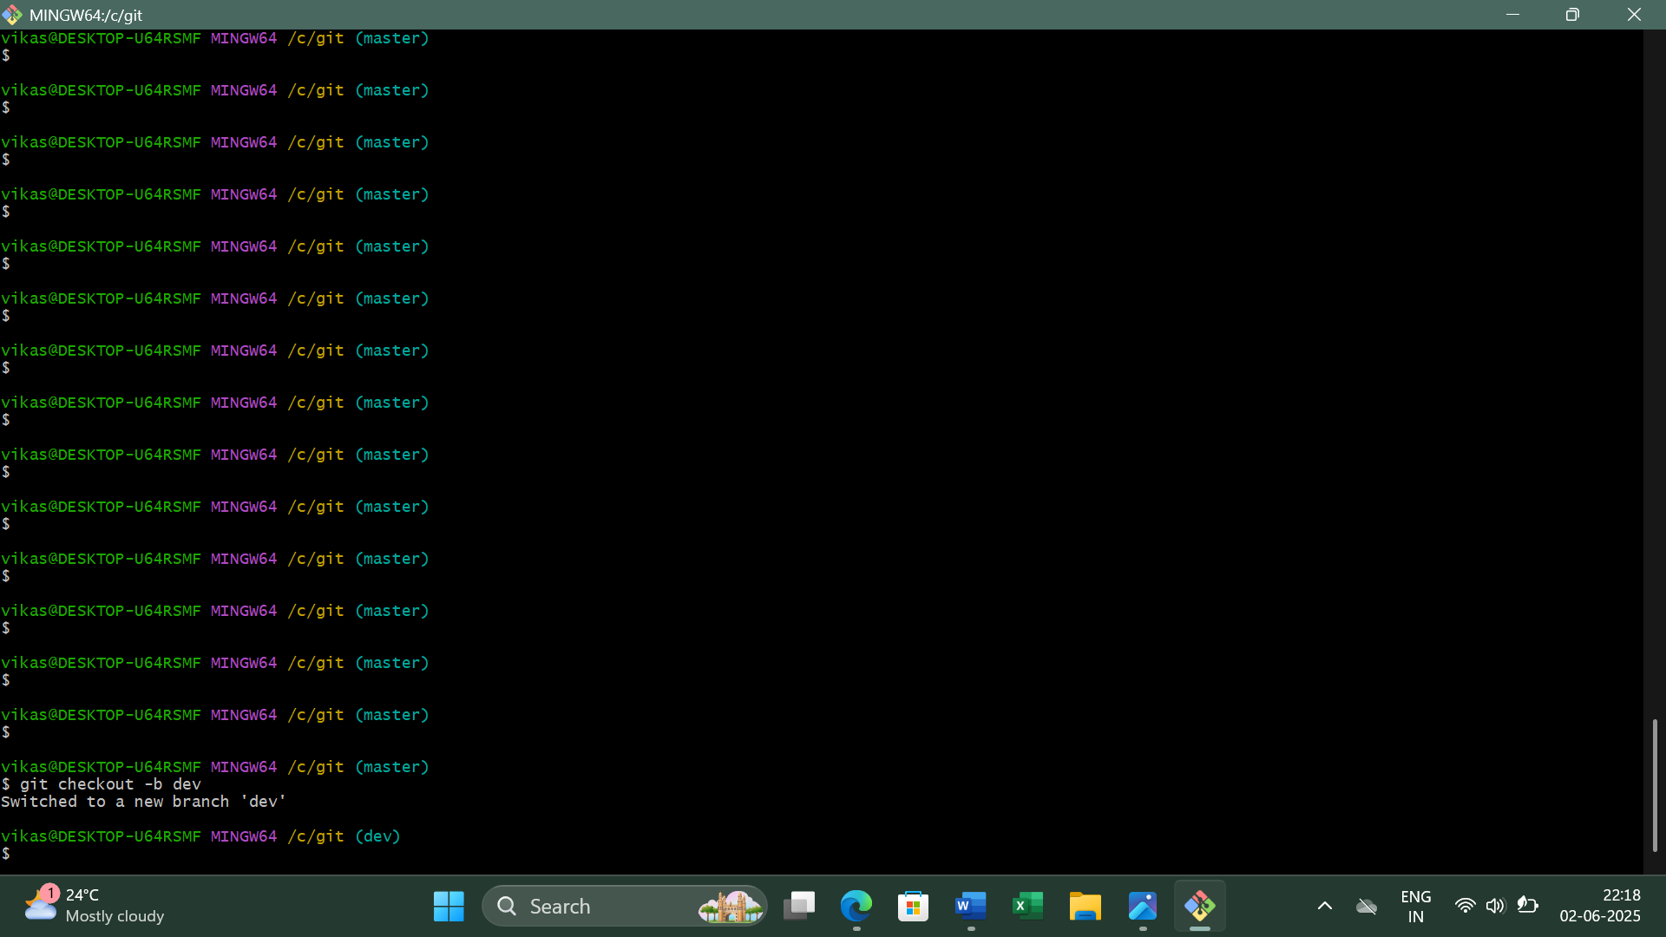

Figure - 1
Step 2: Make Changes in the dev Branch
Open the hello.cpp file and make some changes.
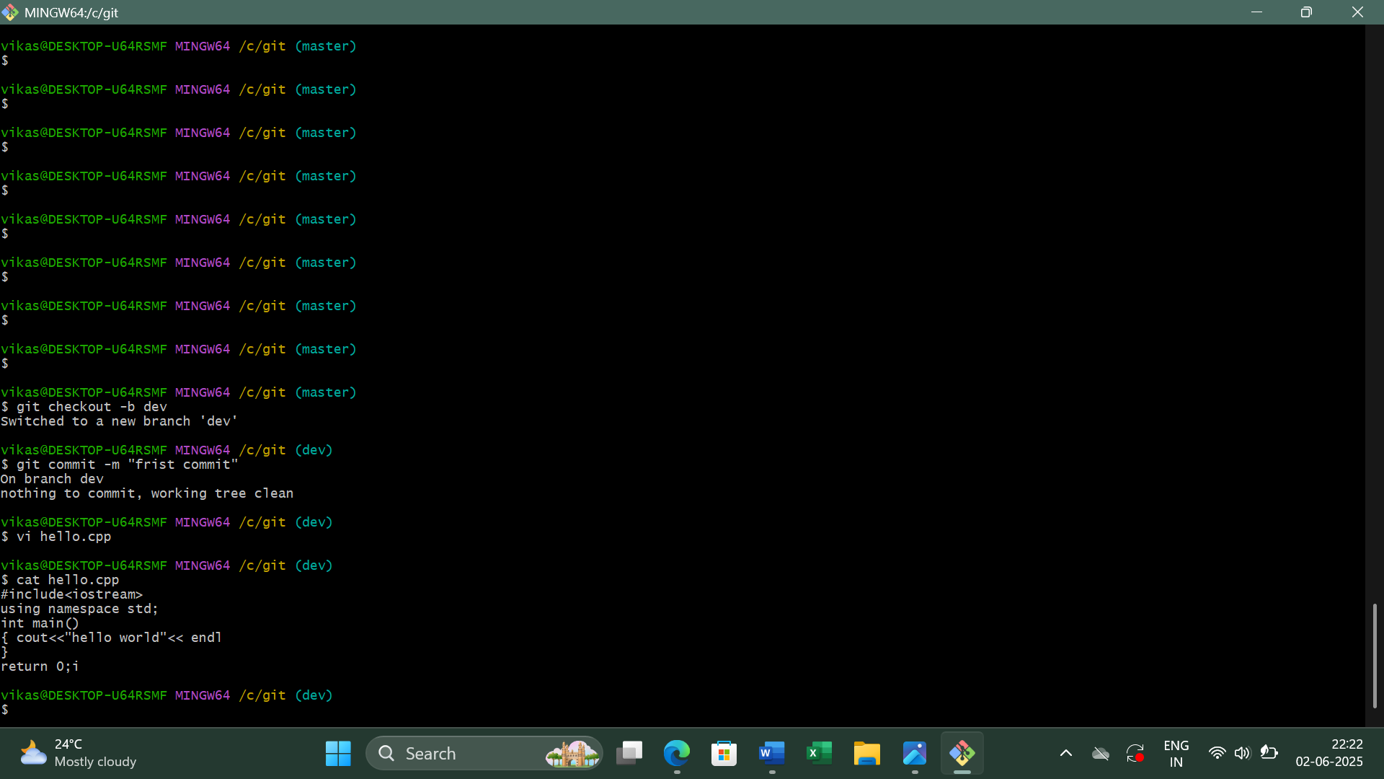

Figure – 2
Step 3: Stage and Commit Changes
- git add .
- git commit -m "Added a new file in dev branch"

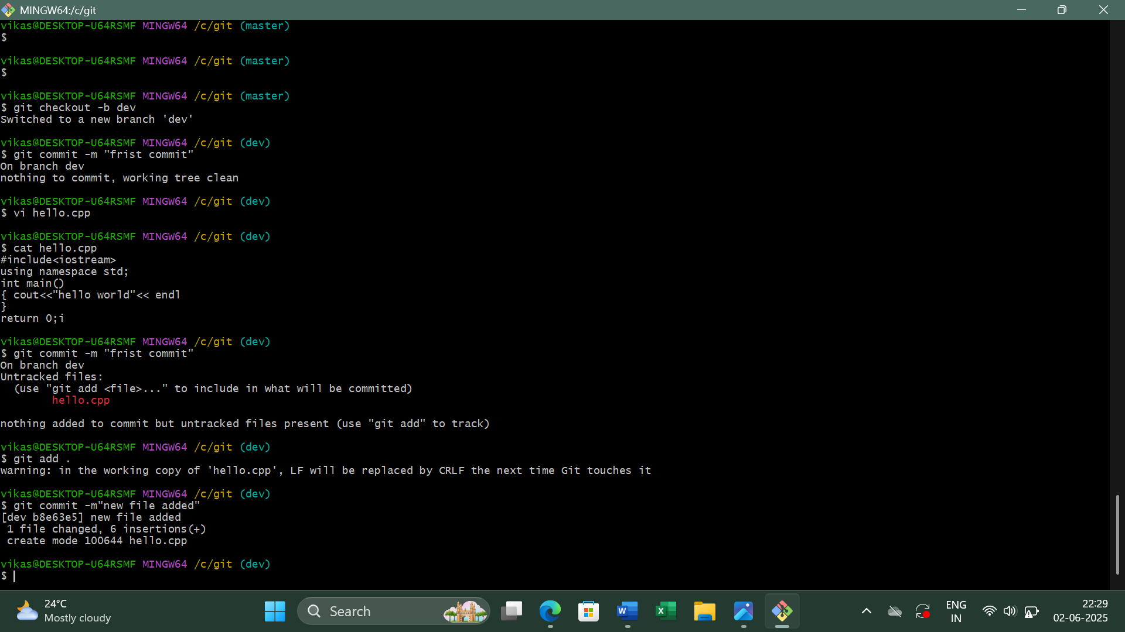

Figure – 3
Step 4: Switch Back to master Branch
git checkout master
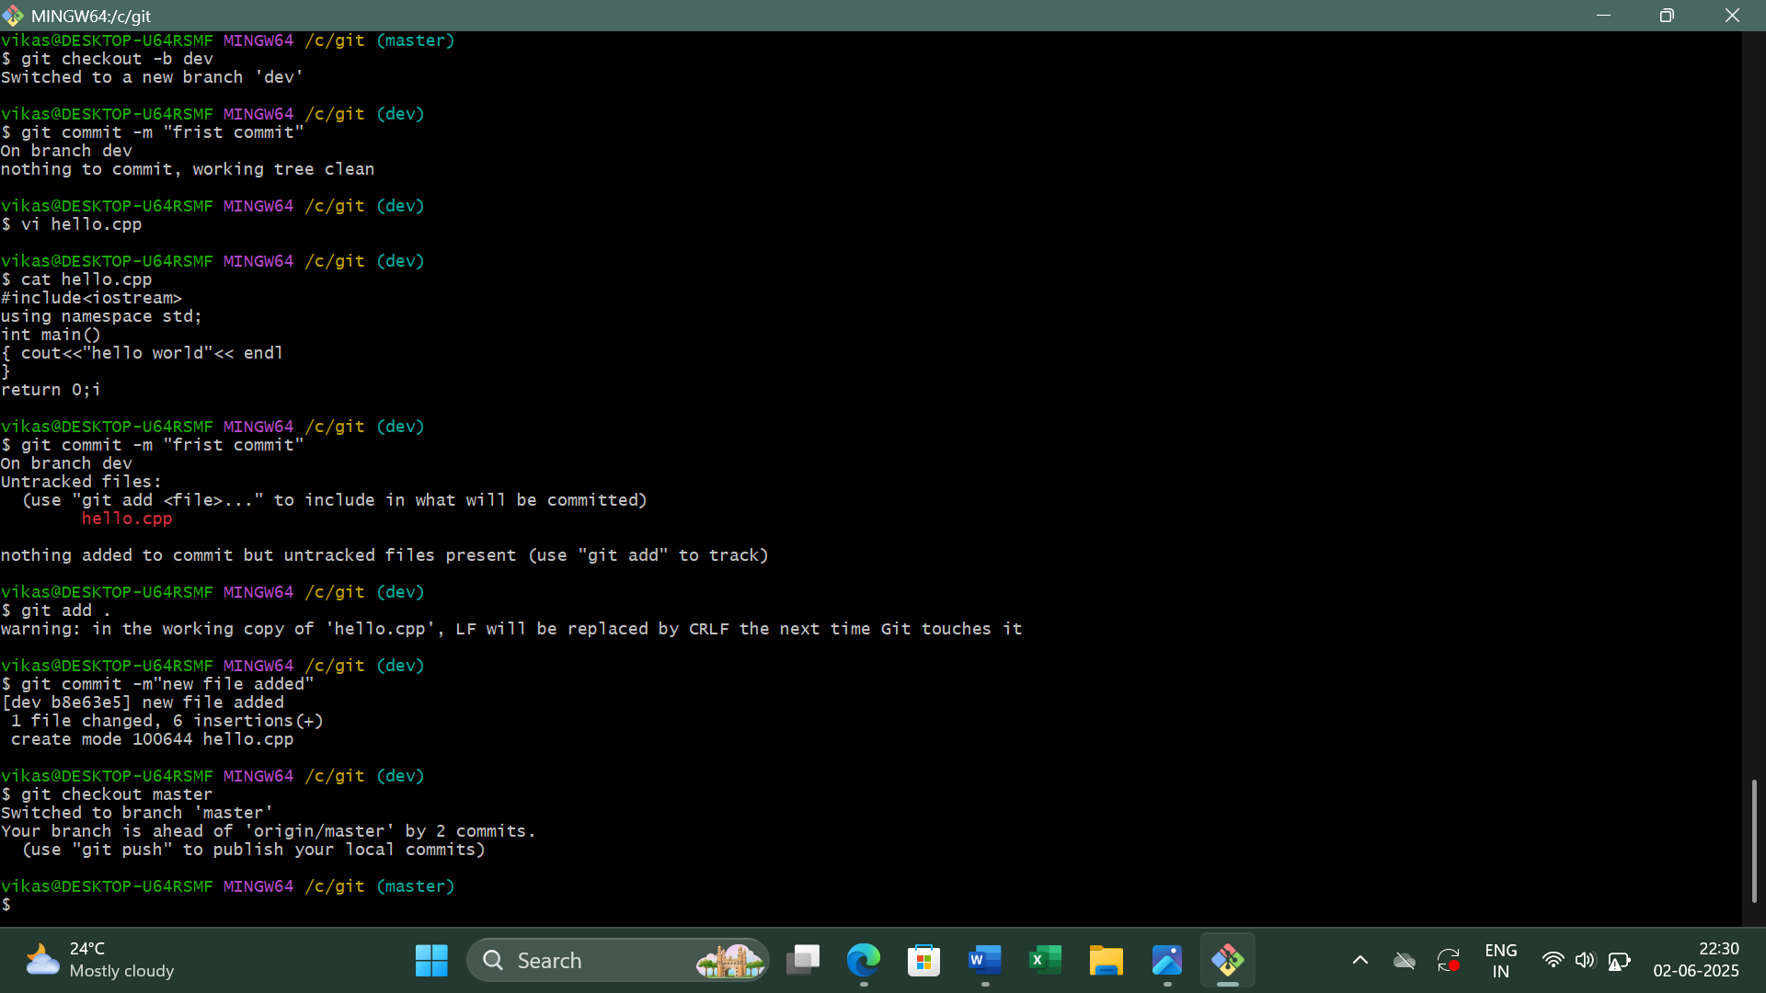

Figure – 4
Step 5: Merge dev into master
If there are no conflicts, this will merge the changes from the dev branch into master.
git merge dev
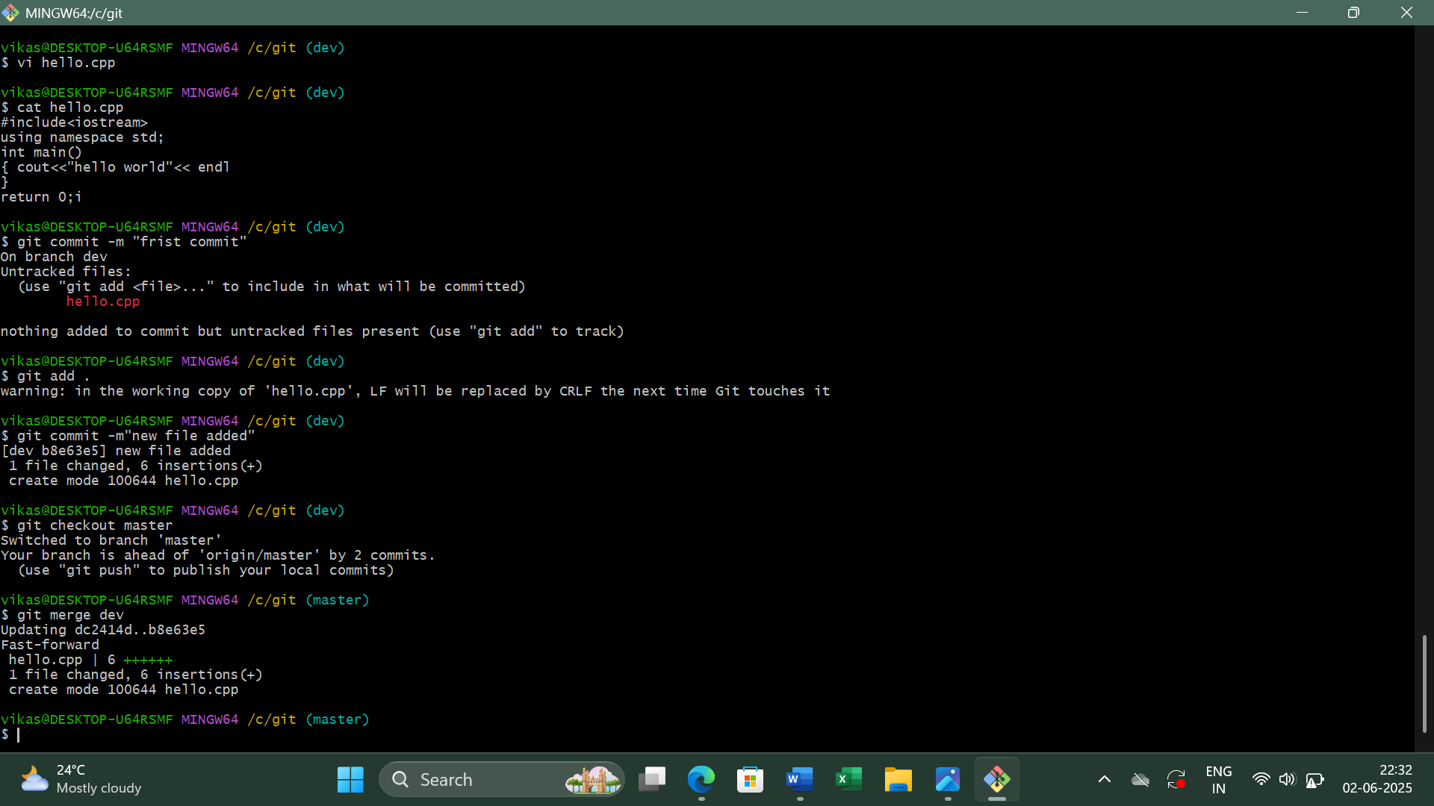

Figure – 5
Step 6: Verify the Merge
Use cat command to check is the files are merged.
cat hello.cpp
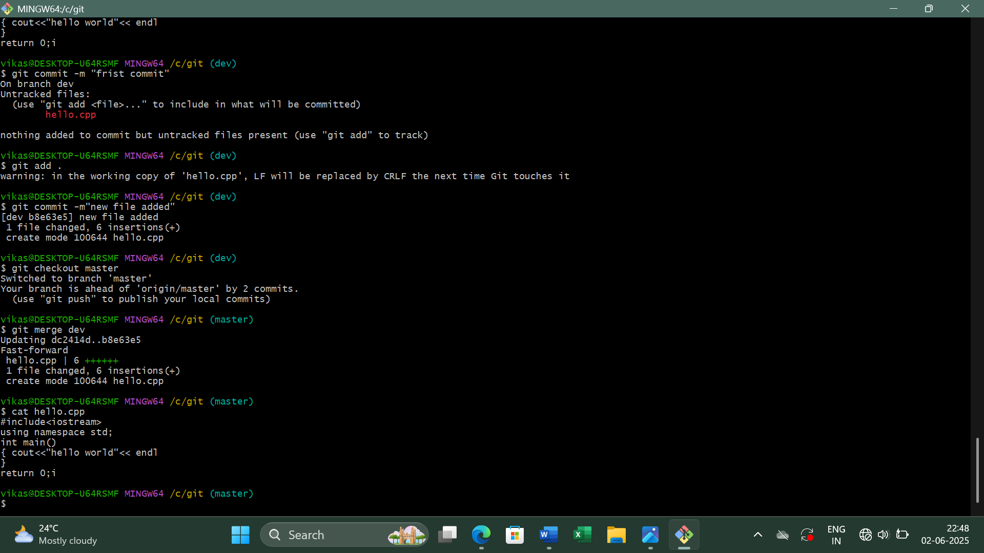

Figure – 6
Step 7: Run the Git Merge Tool
Use git mergetool to open the conflict screen. Close it using escape :wqa
git mergetool
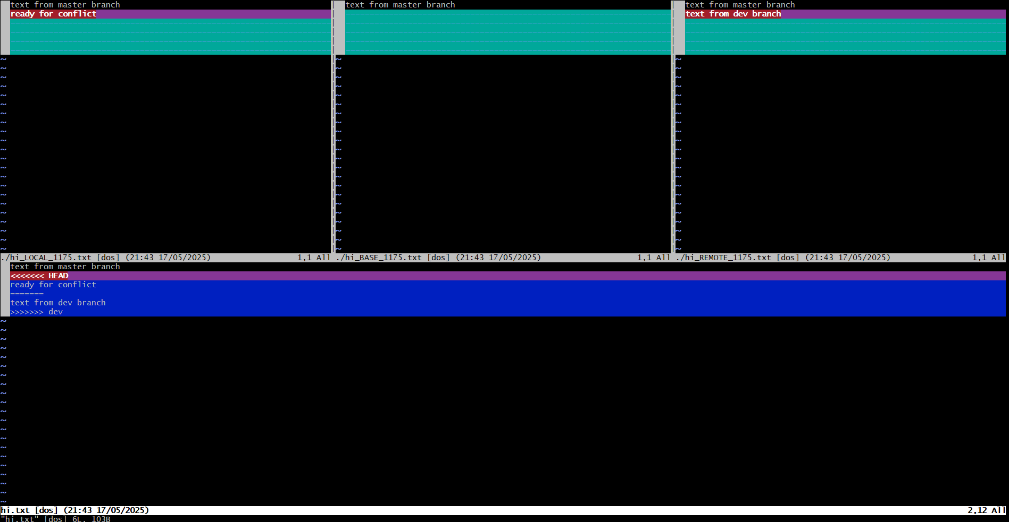

Figure – 7
Step 8: Creating a .gitignore File
The .gitignore file tells Git to ignore specific files or directories that do not need to be tracked, such as log files, build directories, or system files.
touch .gitignore
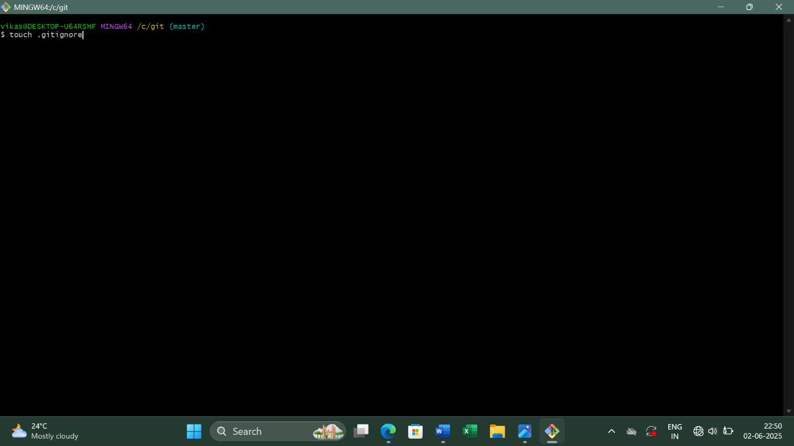

Figure – 8

Step 9: Viewing Hidden Files and Folders
By default, files that start with a dot (.) are hidden in Unix-based systems, including Git Bash.
ls -a
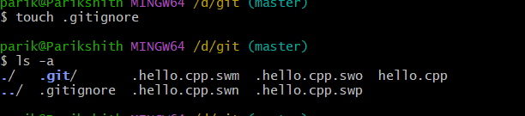

Source Code Management
LAB REPORT – 6
Step 1: Fork a Repository on GitHub
• Go to any public repository on GitHub (e.g., https://github.com/octocat/Hello-World).
• Click on the "Fork" button (top right corner).
• This creates a copy of the repository under your GitHub account.
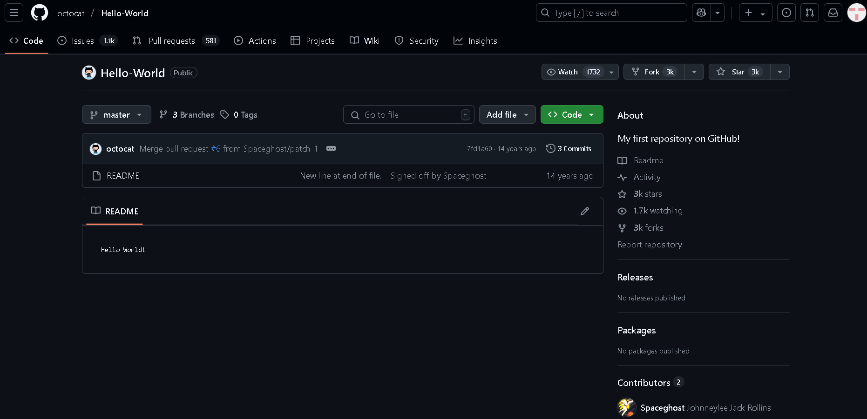
Figure - 1
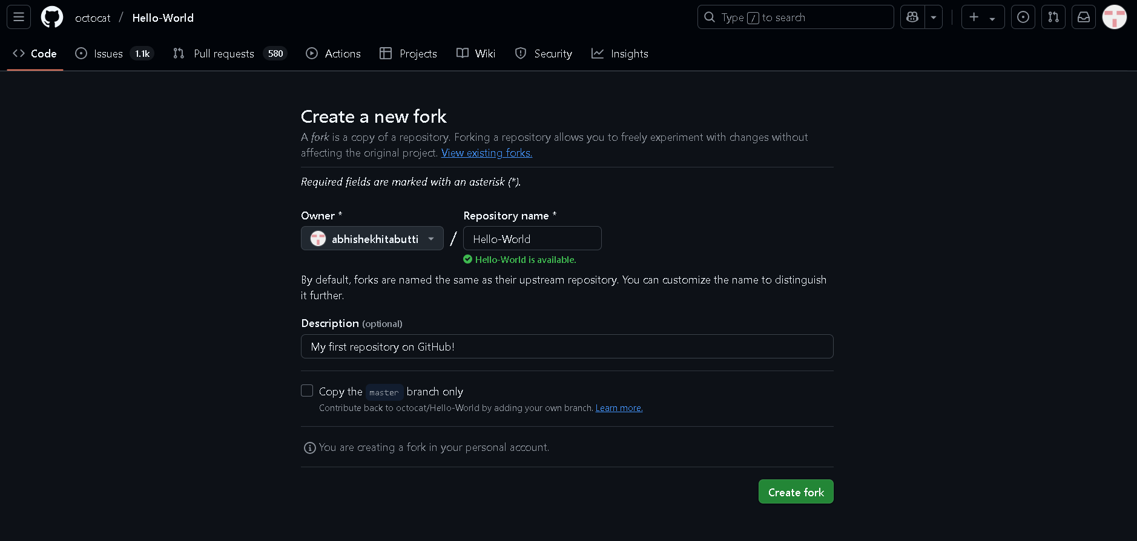
Figure – 2
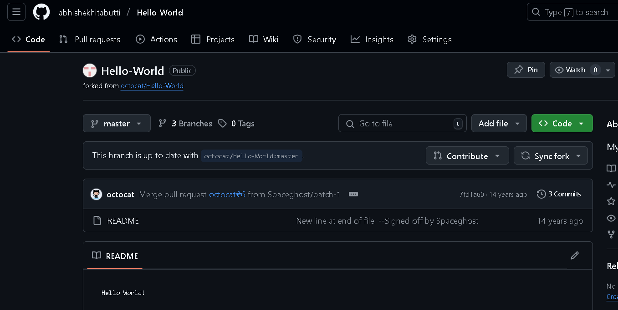
Step 2: Clone the Forked Repository Locally
Replace your-username with your actual GitHub username.
git clone https://github.com/your-username/Hello-World.git
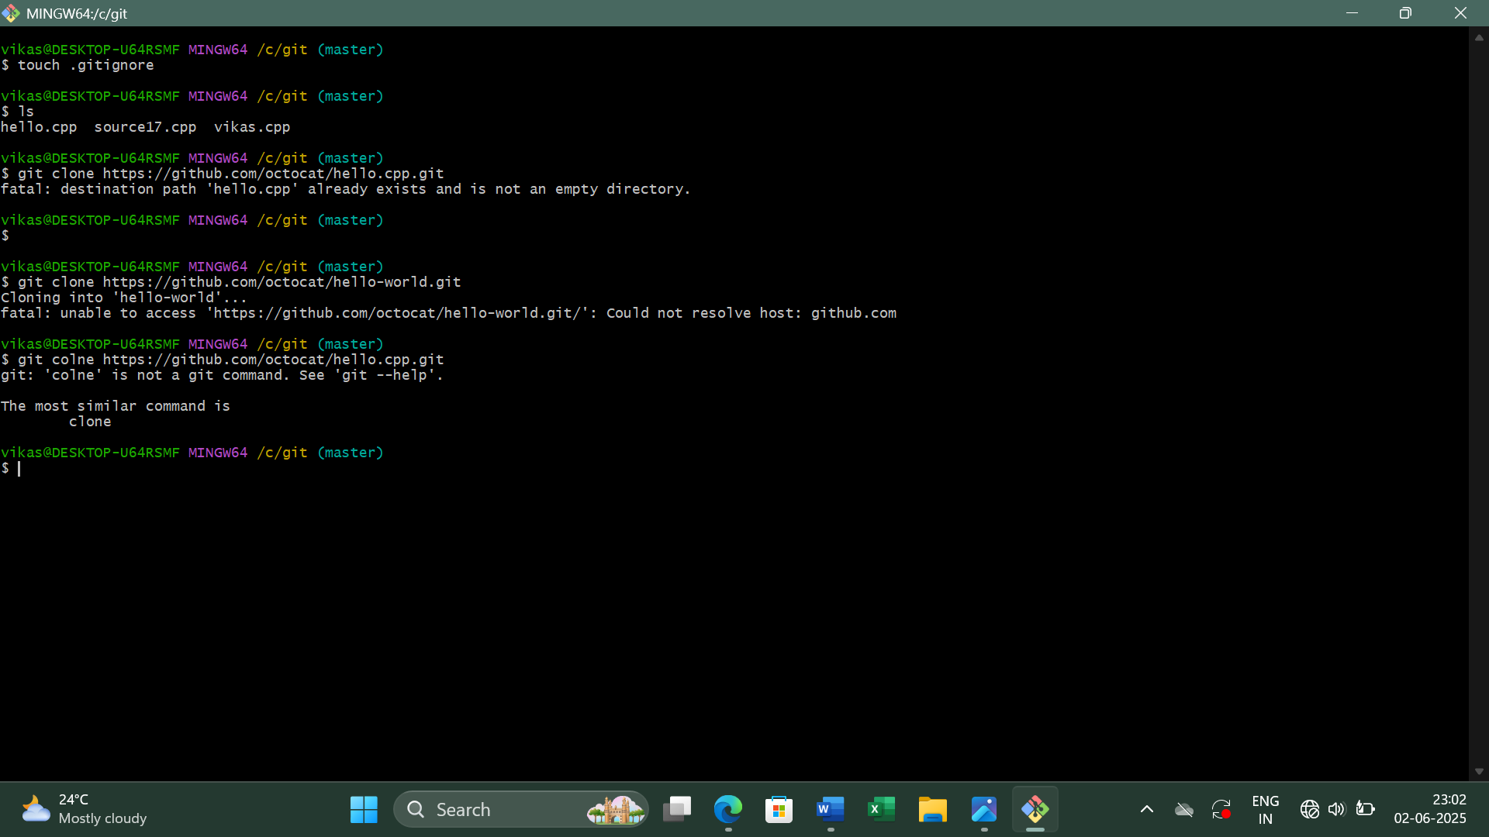

Figure – 3
Step 3: Change Directory to the Cloned Repo
cd Hello-World
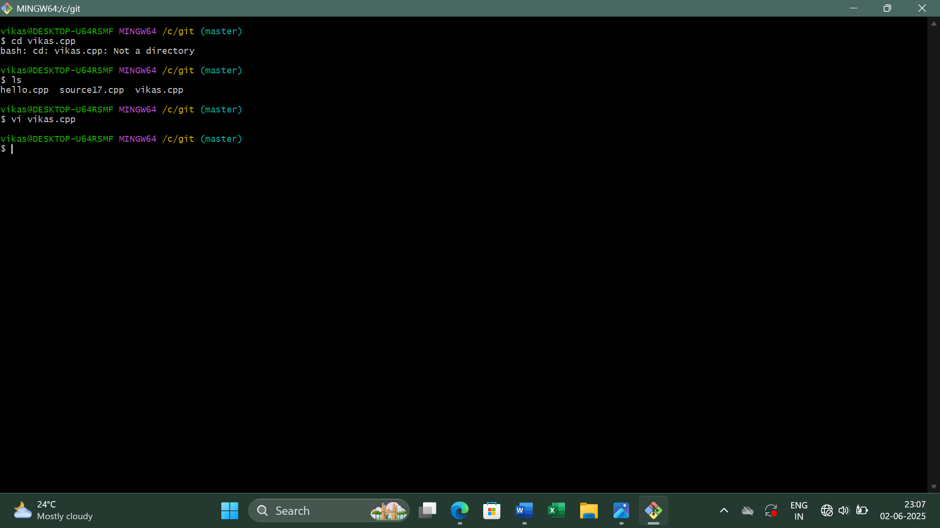

Figure – 4
Step 4: Add a New File or Modify Existing One
Vi hello.cpp


Figure – 5

Step 5: Stage and Commit Your Changes
git add .
git commit -m "First Commit"
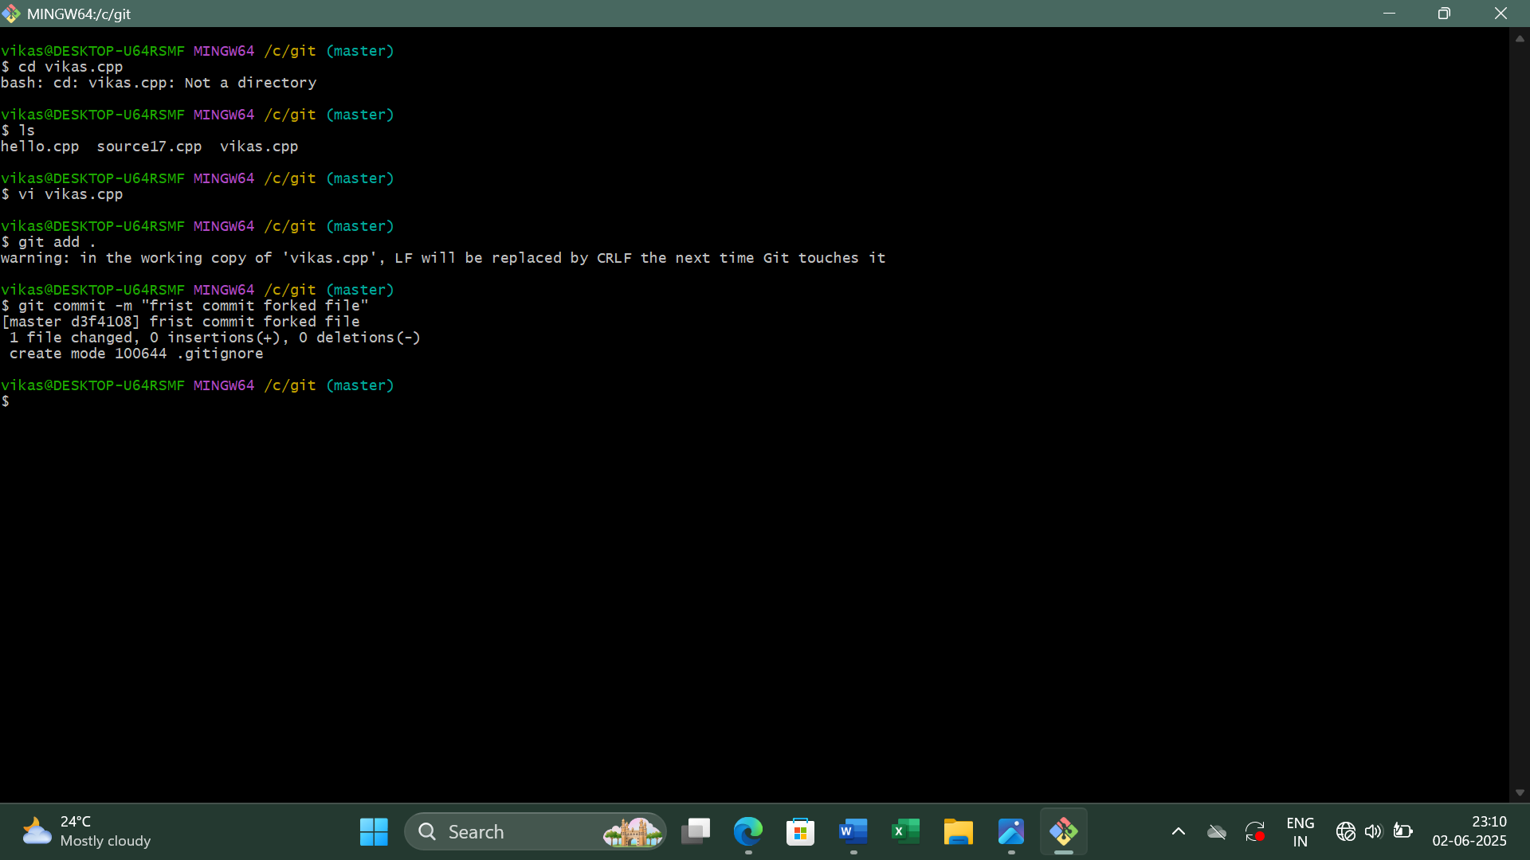

Figure – 6
Step 6: Push Changes to Your Forked GitHub Repo
This updates your forked repository on GitHub with your changes.
git push origin master
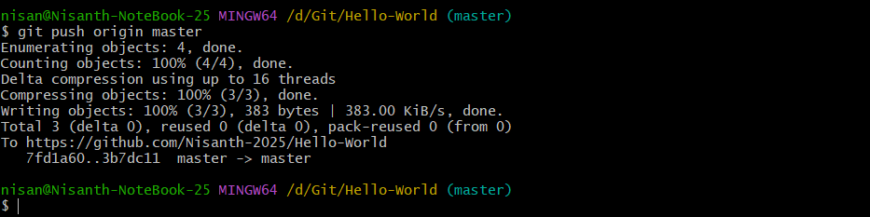
Figure – 7

Step 7: Create a Pull Request
If you want your changes to be added to the original repository:
- Go to your forked repo on GitHub.
- Click "Contribute" > "Open Pull Request".
- Submit your pull request for review.
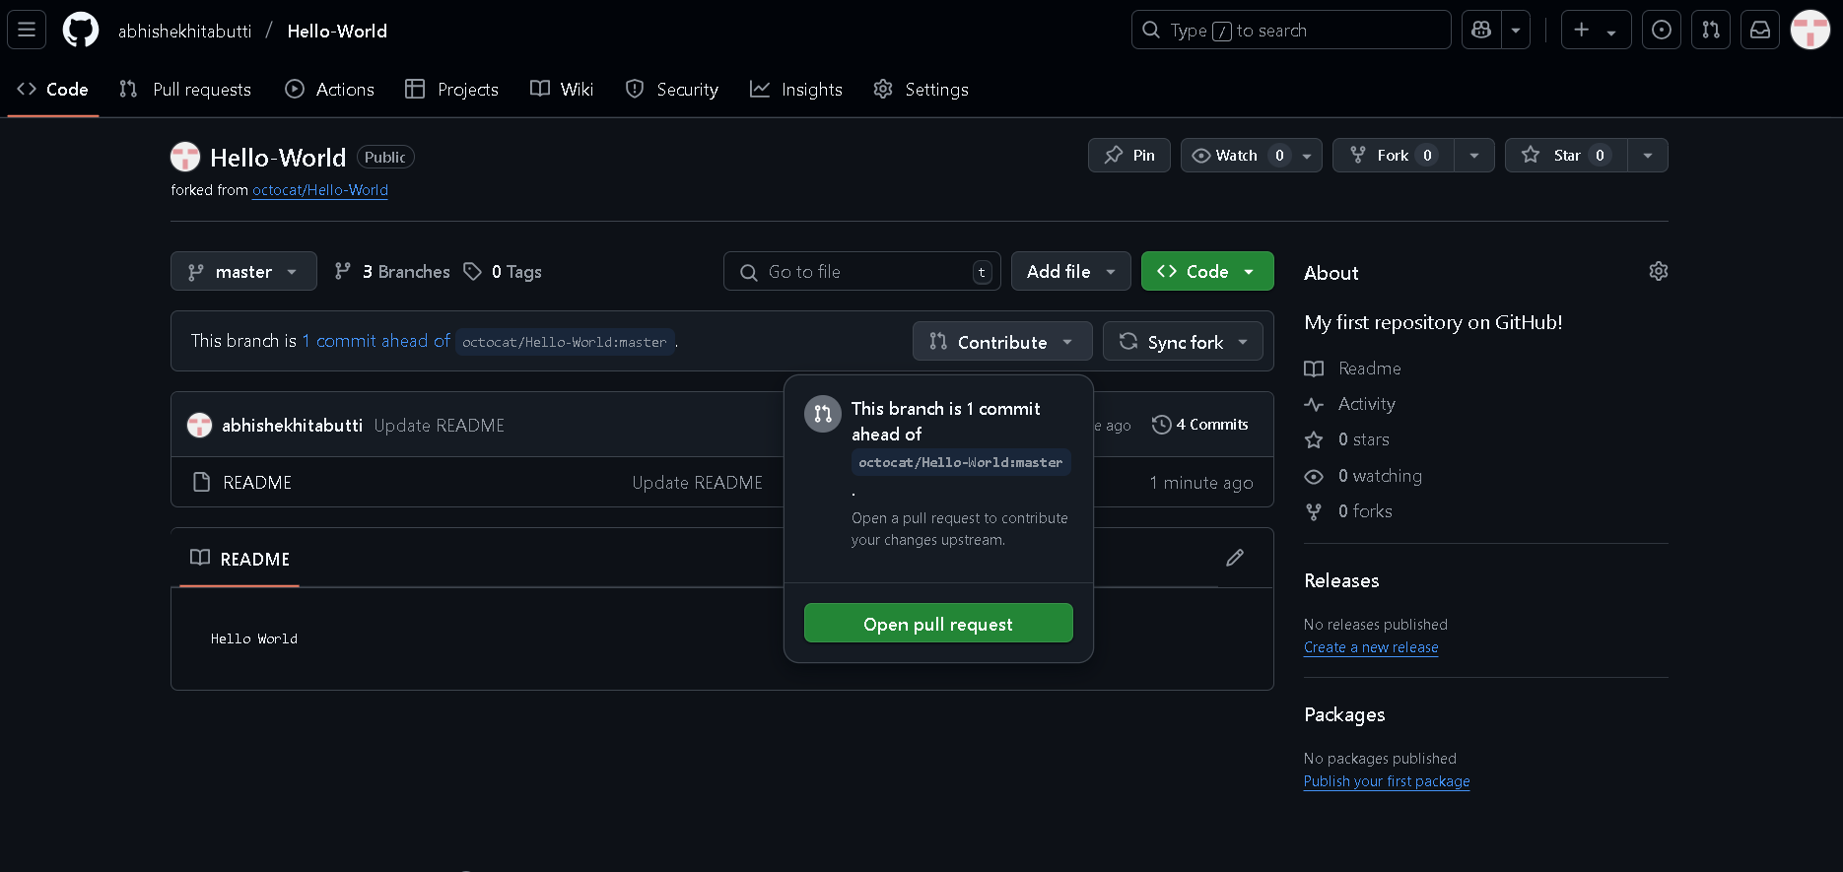
Figure - 8
